Section L
Instructions to Offerors

Multiple Award Construction Contract IV
(MACC IV)

21 August 2020

Table of Contents
SECTION L 4
1.0 PROPOSAL FORMAT 4
1.1 General 4
1.2 Communications 5
1.2.1 Exchange of Information 5
1.2.2 Submission, Modification, Revision, and Withdrawal of Proposals 5
1.2.3 Debriefings 5
1.2.4 Discrepancies 6
1.2.5 Amendments to Solicitation 6
1.3 Volume Organization 6
1.3.1 General 6
1.3.2 Page Limitations 7
1.3.3 Page Size and Format 7
1.3.4 Tables, Charts, Graphs, and Figures 7
1.3.5 Cost or Pricing Information 8
1.3.6 Cross-Referencing 8
1.3.7 Indexing 8
1.3.8 Binding and Labeling 8
1.3.9 Electronic Offers 9
1.3.10 Distribution 9
1.3.11 Proposal Inquiries 9
2.0 VOLUME I, FACTOR 1: COST/PRICE 9
2.1 General 9
2.2 Total Evaluated Price (TEP) Matrix, Section J Attachment 4 10
2.2.1 Rounding 10
2.3 Cost/Price Data 10
2.4 Cost or Pricing Data Requirements 11
2.5 Estimating Techniques and Methods 11
2.6 Accounting System 11
2.7 Consruction Wage Rate Requirements Wage Determiations 11
3.0 VOLUME II, FACTOR 2: TECHNICAL 11
3.1 General 11
3.1.1 Amendments 12
3.1.2 Format and Specific Content 12
3.1.3 Cross Reference Matrix 12
3.2 Technical Approach 12
3.3 Technical Subfactors 12
3.3.1 Subfactor 1: Basic MACC IV Plans 13
3.3.2 Subfactor 2: Architect-Engineer (A-E) Qualifications 13
3.3.3 Subfactor 3: Contractor Requirements: 14
3.3.4 Subfactor 4: Sample Project 15
1.1.1 Safety/Accident Prevention Plan 15
4.0 VOLUME III, FACTOR 3: PAST PERFORMANCE 17
4.1 General 17
4.2 Organizational Structure Change History 18
4.3 Proposal Submittal Information 18
5.0 VOLUME IV: CONTRACT DOCUMENTATION 18
5.1 Solicitation/Representations and Certifications 18
5.1.1 Section A – Solicitation/Contract Form 18
5.1.2 Section B – Supplies or Services and Costs/Prices 19
5.1.3 Section I – Contract Clauses 19
5.1.4 Section J – List of Documents, Exhibits, and Other Attachments 19
5.1.5 Section K – Representations, Certifications, and other Statements of Offerors 19
5.2 Other Information Required 19
5.2.1 Authorized Offeror Personnel 19
6.0 SOLICITATION REQUIREMENTS, TERMS AND CONDITIONS 19
6.1.1 Exceptions to Solicitation Requirements 19
Appendix A: Downloading the PPI Tool 21
Appendix B: Cross Reference Matrix 28
Appendix C: Example Project 29

SECTION L
INSTRUCTIONS, CONDITIONS, AND NOTICES TO OFFERORS OR RESPONDENTS

PROPOSAL FORMAT

General
The following instructions cover the preparation and submittal of the offeror’s proposal for this solicitation. Offerors must follow the instructions contained herein. Offerors are cautioned that any noncompliance with the terms and conditions of the RFP may cause the offeror’s proposal to be determined unacceptable and therefore not eligible for award. If a joint venture arrangement exists for this acquisition, the offeror shall provide a copy of the joint venture agreement that is signed and dated by all joint venture members as part of the proposal submission. Offerors shall submit only one proposal for Multiple Award Construction Contract IV (MACC IV), as the Government will review only one proposal per offeror. Proposals received are subject to the requirements specified in FAR 52.215-1, unless otherwise tailored in an addendum to the solicitation. Proposals must be received by the Contracting Officer at 6038 Aspen Ave. Bldg. 1289 NE, Hill Air Force Base, UT 84056, Attention: Ms. Emily J. McCollaum, no later than the date and time specified in Section A of the solicitation. However, Offerors are requested to submit Volume III Past Performance Information, so that it is received ten (10) calendar days prior to the required due date for proposals. Failure to submit Volume III by the earlier date will not result in Offeror disqualification.
The Government anticipates awarding 7-8 Indefinite Delivery Indefinite Quantity (IDIQ) contract for MACC IV. However, the Government reserves the right to award more or fewer total contracts if the Source Selection Authority (SSA) determines it is in the best interest of the Government. The purpose of this effort is to establish a MACC IV which is an Indefinite-Delivery, Indefinite- Quantity (IDIQ) - design-build contract covering multiple disciplines in general construction to be managed by the 75th Civil Engineering Group (CEG) at Hill Air Force Base (HAFB) and Utah Air National Guard Base (UAGB), Utah. Project locations may also include remote sites such as Boulder Seismic Station Pinedale, Wyoming; Little Mountain, Utah; Utah Test and Training Range (UTTR); and Carter Creek, Utah.
The proposal shall be clear concise, and shall include sufficient detail for effective evaluation and for substantiating the validity of stated claims. The offeror’s proposal shall provide a description addressing how the offeror intends to meet the Government’s requirements and evidence of the effectiveness and ability to execute proposed methodology.
Elaborate brochures or documentation, binding, detailed art work, or other embellishments are unnecessary and not desired.
The proposal acceptance period is specified in Section A of the solicitation. The offeror shall make a clear statement in Section A of the proposal documentation volume that the proposal is valid for a minimum of 365 days from the solicitation closing.
In accordance with (IAW) FAR Subpart 4.8, Government Contract Files, the Government will retain one copy of all unsuccessful proposals. Unless the offeror requests otherwise, the Government will destroy extra copies of such unsuccessful proposals.

Communications
The Procuring Contracting Officer (PCO) is the sole point of contact for this acquisition. The offeror shall address any questions, concerns or requests for clarification to Emily J. McCollaum at emily.mccollaum.2@us.af.mil (preferred) or the mailing address cited in paragraph 1.1. When appropriate, answers to questions and concerns will be made available to all offerors.

Exchange of Information
Exchanges of source selection information between Government and offerors will be controlled by the PCO. Email may be used to transmit such information only if the email can be sent encrypted, and must include “Source Selection Information – See FAR 2.101 and 3.104” in the subject line of the email. Otherwise, source selection information will be transmitted via direct mail. In order to facilitate the sending and receiving of encrypted emails, offerors must use MS Outlook email configured to support encryption or a different email product that is S/MIME compatible and configured to support encryption. If you intend to submit your source selection information via encrypted email, you will need to contact the Buyer/Contracting Officer indicated on the face page of the solicitation prior to that first submittal in order to exchange certificates used for encryption. To ensure the process is working correctly, send a test encrypted message first (without including any source selection information).

Submission, Modification, Revision, and Withdrawal of Proposals
Proposals and modifications to proposals shall be submitted in both paper and electronic media to the address located in paragraph 1.1. of this document, showing the time and date specified for receipt, the solicitation number, and the name and address of the offeror. Late proposals will only be considered IAW FAR 15.208.
Proposals may be withdrawn by written notice received at any time before award. Proposals may also be withdrawn in person by an offeror or an authorized representative, if the identity of the person requesting the withdrawal is established and the person signs a receipt for the proposal before award.

Debriefings
The PCO will notify offerors of any decision to exclude them from the competitive range; whereupon they may request and receive a debriefing IAW FAR 15.505, Pre-Award Debriefing of Offerors. Offerors excluded from the competitive range may request a pre-award debriefing or they may notify the Contracting Officer of their choice to wait until after the source selection decision to request a post-award debriefing. However, offerors excluded from the competitive range are entitled to no more than one debriefing.
The PCO will notify unsuccessful offerors in the competitive range of the source selection decision IAW FAR 15.503, Notifications to Unsuccessful Offerors. Upon such notification, unsuccessful offerors may request and receive a debriefing. Offerors desiring a debriefing must make the request IAW the requirements of FAR 15.505 or 15.506, as applicable.

Discrepancies
If an offeror believes that the requirements in these instructions contain an error, omission, or are otherwise unsound, the offeror shall immediately notify the PCO in writing with supporting rationale, as well as the remedies the offeror is asking the PCO to consider as related to the omission or error.

Amendments to Solicitation
If this Request for Proposal (RFP) is amended, all terms and conditions that are not amended remain unchanged. If the RFP is amended prior to proposal delivery, offerors shall acknowledge each amendment by signing and returning the front page of each amendment with the proposal submission. If the RFP is amended after proposal submission, offerors shall respond by the date and time specified in the amendment to include a signed front page of the amended RFP.

Volume Organization

General
The offeror shall prepare the proposal as set forth in the Proposal Organization Table below. The titles and contents of the volumes shall be as defined in this Table, all of which shall be within the required page limits and with the number of copies as specified. The volumes identified in the Table shall be separately bound in the three-ring, loose-leaf binders.
The title page of each volume must show:
- Solicitation Number
- Company name, address, Commercial and Government Entity (CAGE) Code and Data Universal Numbering System (DUNS) Number
- Primary point of contact name, telephone number and email address
- Volume number and name (e.g. Volume I, Cost/Price) and copy number (i.e. Original, Copy 1, Copy 2)
Table 1: Proposal Organization
Volume | Volume Title | Total Page Limits | Number of Paper Copies | Number of Electronic Copies | Description
I | Price | N/A | 0 | 2 (Original and 1 copy) | Cost/Price Volume
II | Technical | 200 | 6 | 2 (Original and 1 copy) | Technical Volume  Sub-factor 1:  - 100 pages, excluding Safety Plan  Safety Plan – unlimited pages  Sub-factor 2: 50 pages  Sub-factor 3: 50 pages
III | Past Performance | 3 pages per submission | 1 | 2 (Original and 1 copy) | Past Performance Volume
IV | Contractual Documentation | N/A | 0 | 2 (Original and 1 copy) | Contractual Documentation Volume  - RFP compliance  - Other Information

Page Limitations
Individual page limitations shall be treated as maximums. If exceeded, the excess pages will not be read or considered in the evaluation of the proposal and (for paper copies) will be shredded. If Evaluation Notices (ENs) are issued, page limitations may be placed on responses. The specified page limits for EN responses will be identified in the letters forwarded with the ENs to the offerors. Each page shall be counted except the following: blank pages, title pages, tables of contents, lists of tables and drawings, cross-reference matrices, tabs, and glossaries.

Page Size and Format
A page is defined as each face of a sheet of paper containing information. When both sides of a sheet display printed material, it shall be counted as two pages. Page size shall be 8.5 x 11 inches, not including foldouts. Except for the reproduced sections of the solicitation document, the text size shall be Times New Roman font and no less than 12 point. Tracking, kerning, and leading values shall not be changed from the default values of the word processing or page layout software. Use at least 1-inch margins on the top and bottom and ¾-inch side margins. Pages shall be numbered sequentially by volume. These page size and format restrictions shall apply to responses to ENs. These limitations shall apply to both electronic and hard copy proposals.

Tables, Charts, Graphs, and Figures
Organizations, systems and layout, implementation schedules, plans, etc. shall be depicted in tables, charts, graphs, or figures wherever practical. These items shall be uncomplicated, legible and shall not exceed 11 x 17 inches in size. Foldout pages shall fold entirely within the volume, and count as a single page. Foldout pages may only be used for large tables, charts, graphs, diagrams, and schematics, not for pages of text. For tables, charts, graphs and figures, the text shall be no smaller than Times New Roman 10 point and searchable for text in Microsoft (MS) Office Word and/or PDF formats to the maximum practical extent. Ensure all tables, foldouts, graphics, and figures in the electronic version of the proposal are pasted into the proposal in a format that allows a word search by the host program (do not paste as pictures) to the maximum practical extent. These limitation shall apply to both electronic and hard copy proposals.

Cost or Pricing Information
All cost or pricing data shall be addressed in the Technical Volume, Cost/Price Proposal Volume and Contract Documentation Volume. If there is a discrepancy in the cost or pricing data between the three volumes, the Cost/Price Proposal, Volume I, shall take precedence.

Cross-Referencing
Each volume shall be written on a stand-alone basis so that its contents may be evaluated without cross-referencing to other volumes of the proposal. Information required for proposal evaluation which is not found in its designated volume will be assumed to have been omitted from the proposal.
Cross-referencing within a proposal volume is permitted where its use would conserve space without impairing clarity, but must be hyperlinked IAW Section 1.3.9.

Indexing
Each volume shall contain a more detailed table of contents to delineate the subparagraphs within that volume. Tab indexing shall be used to identify sections. Tables of contents do not count against the page limits for the offeror’s respective volumes.
Each volume shall contain a glossary of all abbreviations and acronyms used, and with an explanation for each. Glossaries do not count against the page limitations for the offeror’s respective volumes.

Binding and Labeling
The Technical Volume of the proposal should be separately bound in a three-ring, loose-leaf binder permitting the volume to lie flat when open. Staples shall not be used. The outside of each Technical Volume binder shall include a cover sheet, clearly marked, identifying volume number, title, copy number, solicitation identification, and the offeror's name. The same identifying data should be placed on the spine of each binder. Be sure to apply all appropriate markings including those prescribed IAW FAR 52.215-1(e), Restriction on Disclosure and Use of Data and FAR 3.104-4, Disclosure, Protection, and Marking of Contractor Bid or Proposal Information and Source Selection Information. Any page containing proprietary information should be so marked.

Electronic Offers
The content and page size of electronic copies must be identical to the hard copies. In the event there is a discrepancy between the hard copy and the electronic copy, the hard copy shall take precedence and will be used for evaluation. The offeror shall submit Volumes I through IV in electronic format, using virus-free CD-R or DVD-R. In no cases shall the offeror use CD-RW or DVD-RW. The offeror shall indicate on each CDs/ DVD the Volume Number, Volume Title, Company’s name, solicitation number and either “Original Copy” or “Backup Copy”. Each volume shall be on a separate CD/DVD. Use separate files to permit rapid location of all portions, including subfactors, exhibits, annexes, and attachments, if any. The file naming shall specify the appropriate volume number, volume title and a descriptive identifier. If files are compressed, the necessary decompression program must be included. The electronic copies of the proposal shall be submitted in a format readable and searchable by MS Office Word, Adobe PDF, and MS Office Excel (2016 or later).
The Table of Contents of all proposal volumes shall be hyperlinked to the corresponding material within each proposal volume such that clicking the mouse on an item in the Table of Contents will take the reader to the corresponding section within the body of the proposal volume. Any heading or sub-heading appearing in the Table of Contents shall be hyperlinked as described above. The Table of Contents shall include the file names, as well as page numbers where content is cross-referenced between subfactors. Also, any reference within the body of the proposal volume that refers the reader to another location within the referring document shall be hyperlinked in the manner described above. Hyperlinking references between different filenames is not necessary.

Distribution
The proposal shall be addressed to the PCO and mailed or hand-carried to the address cited in paragraph 1.1. Delivery of proposals shall be coordinated at least 24 hours in advance of the due date/time with the PCO. Proposals received after the due date and time specified in the solicitation shall be treated IAW FAR 15.208, Submission, Modification, Revision, and Withdrawal of Proposals.
Offerors are cautioned that Hill AFB has visitor control procedures requiring individuals not affiliated with the installation to obtain a visitor pass prior to entrance. Some delay should be anticipated when hand-delivering proposal packages. Offerors should allow for sufficient time to obtain a visitor pass and arrive at the specified office PRIOR to the time specified for receipt of proposals.

Proposal Inquiries
All inquiries must be submitted via e-mail or mail to the PCO. Questions, if appropriate as determined by the Government, will be answered as quickly as possible, during the proposal preparation period. When appropriate, answers to questions and concerns will be made available to all offerors.

VOLUME I, FACTOR 1: COST/PRICE

General
The Price Volume should be specific and include all information required of Volume I. Compliance with these requirements is mandatory and failure to comply may result in rejection of the offeror’s proposal. Note that unrealistically low or unreasonably high proposed costs or prices, initially or subsequently, may be grounds for eliminating a proposal from competition either on the basis that the offeror does not understand the requirement or has submitted an unrealistic proposal. Additionally, unbalanced pricing poses an unacceptable risk to the Government and may be a reason to reject the offeror’s proposal. Offers should be sufficiently detailed to demonstrate reasonableness. The burden of proof for credibility of proposed costs/prices rest with the offeror.

Offeror’s responses will be evaluated in the following areas as defined in Section M of the RFP:

- Completeness
- Reasonableness
- Balance
- Total Evaluated Price (TEP)

The Cost/Price Volume shall be organized according to the following general outline:

Section | Title
1 | Table of Contents
2 | Listing of Abbreviations and Acronyms (used within cost/price volume)
3 | General
3-1 | TEP Matrix Worksheet
3-2 | Accounting System

Total Evaluated Price (TEP) Matrix, Section J Attachment 4
Offerors shall input into the TEP Matrix, located in Section J, Attachment 4, Not-to-Exceed (NTE) fully burdened rates for all labor categories and years. Fully burdened rates shall include direct labor rates, all direct costs, indirect costs (overhead, General and Administrative, Fringe Benefits, etc.) and profit necessary for the performance of the entire requirement. The formula for application of hours and the notional hours used will not be disclosed to the offerors. The TEP is for evaluation purposes only; however, all proposed fully burdened NTE rates and formula results and numbers directly entered for the Awardable Program Management Sample Project are contractually binding.
Submit a copy of the completed TEP Matrix in Cost/Price Volume I in MS Excel (non PDF format).

Rounding
All fully burdened labor rates provided shall be rounded to the nearest penny.

Cost/Price Data
Data beyond that required by this instruction shall not be submitted, unless the offeror considers it essential to document or support its cost/price position. All data relating to the proposed price, including all required supporting documentation, must be included in the section of the proposal designated as the Price Volume. Under no circumstances shall this data and documentation be included elsewhere in the proposal.

Cost or Pricing Data Requirements
In accordance with FAR 15.403-1(b) and 15.403-3(a), data other than certified cost or pricing data may be required to support a determination of price reasonableness. Data shall be provided IAW FAR 15.403-5, Instructions for Submission of Certified Cost or Pricing Data and Data other than Certified Cost or Pricing Data. If, after receipt of proposals, the PCO determines that there is insufficient data available to determine price reasonableness and none of the exceptions in FAR 15.403-1, Prohibition on Obtaining Certified Cost or Pricing Data (10 U.S.C. 2306a and 41 U.S.C. 254b) apply, the offeror shall be required to submit additional cost or pricing data.

Estimating Techniques and Methods
Offerors shall use generally accepted estimating techniques to develop their estimates for the proposed rates.

Accounting System
Small Business’ are not required to be Cost Accounting Standards (CAS) compliant; however, the Offeror must have an accounting system adequate for determining costs applicable to the contract.

Construction Wage Rate Requirements Wage Determinations
The rates proposed for the various Wage Determinations (Section J Attachments 34-39) will also be evaluated to ensure they meet or exceed the rates in the applicable Construction Wage Rate Requirements Wage Determinations.

VOLUME II, FACTOR 2: TECHNICAL

General
The Technical Volume should be specific and include all requirements of Volume II. Offeror’s responses will be evaluated against the Technical subfactors defined in Section M, Evaluation Factors for Award. Using the instructions provided below, the offeror shall provide as specifically as possible the actual approach, methodologies, capabilities it would use for satisfying these subfactors. All the requirements specified in the solicitation are mandatory. By its proposal submission, the offeror is representing that its firm will perform all the requirements specified in the solicitation. The offeror shall not merely reiterate the objectives or reformulate the requirements specified in the solicitation.
The Technical Volume shall be organized according to the following general outline:
Section | Title
1 | Table of Contents
2 | List of Tables and Drawings
3 | Glossary
4 | Cross Reference Matrix
5 | Subfactor 1 – Technical/Management Proficiency
6 | Subfactor 2 – Technical Approach
7 | Subfactor 3 – Management Approach
8 | Subfactor 4 – Sample Project

Amendments
For any amendment to Volume II, the offeror’s proposal will include a cover letter delineating any changes from initial proposal, to include changes/revisions (if needed) for Final Proposal Revisions (FPR).

Format and Specific Content
The information in paragraphs 3.2 - 3.3 shall be provided in the written technical proposal and will be used to assess the proposed technical approach in accordance with Section M, Evaluation Factors for Award. The written technical proposal shall address each of the following to describe the offeror’s proposed approach, methodologies, and capabilities in performing the requirements set forth in the subfactors.

Cross Reference Matrix
The offeror shall fill out the Cross Reference Matrix (Section L: Appendix B), and submit with the proposal indicating where in its proposal the information can be found as it relates to the PWS, Section L, and Section M. The cross reference matrix will help an offeror ensure it has responded to all the evaluation criteria and proposal submittal requirements identified in the solicitation. If the matrix conflicts with any other requirement, direction, or provision of this solicitation, the other reference shall take precedence over the matrix. Section M references in the matrix are for informational purposes only, and the Government will evaluate proposals solely in conformance with Section M of the solicitation. This matrix will be used for reference only and will not become contractually binding.

Technical Approach
The following information shall be provided in the written technical proposal and will be evaluated to assess technical acceptability in accordance with Section M. The written technical proposal shall address each of the following subfactors to describe the offeror’s proposed approach to performing the requirements set forth in the Basic MACC IV SOW and Sample Project SOW.

Technical Subfactors
Subfactor 1 – Basic MACC IV Plans
- Safety Plan
- Construction Quality Control (CQC) Plan
Subfactor 2 – Architect Engineer (A-E) Qualifications
Subfactor 3 – Contractor Requirements
Subfactor 4 – Sample Project Order
- Milestone Schedule
- Safety/Accident Prevention Plan
- Construction Quality Control (CQC) Plan
- Demolition Plan
- Civil Plan
- Architectural Plan
- Security Plan
- Concrete Structural Design
- Concept Mechanical Drawing
- Electrical Plan
- Fire Protection Plan

Subfactor 1: Basic MACC IV Plans
The offeror shall submit an approach for the Sample Project. The offeror shall describe in detail the offeror’s approach to each el4ment within Subfactor 1.

Safety Plan
Offeror shall submit an initial Contract Occupational Safety and Health Plan that meets the requirements outline in MACC IV Basic SOW, Section 3.3.1 and Appendix C.

Construction Quality Control (CQC) Plan
Offeror shall submit an initial Contraction QCP that meets the requirements outlined in MACC IV Basic SOW Section 3.1 and IAW UFGS 01 45 00. The offeror’s Construction QCP shall comply with the UFGS specification and shall include a detailed and mature approach of task order project management to include procedures to identify and prevent defective services from reoccurring; interim status reports; and remediation and change management procedures to meet and maintain schedule milestones. In addition the offeror’s QCP shall include in detail the testing necessary for material control and shall include how the mechanical systems will be commissioned.

Subfactor 2: Architect-Engineer (A-E) Qualifications
The Offeror shall submit detailed and complete documentation described within each element of this subfactor to meet the MACC IV A-E requirements in Basic MACC IV SOW Section 1.5.1.5. Past project examples shall be formatted IAW Section L, Appendix C
- One (1) example of the A-E firm’s past project containing short circuit, coordination, arc flash and voltage drop calculations. The example project shall be similar in scope in regards to complexity, cost, and size of the Sample Project (Subfactor 4). Example project shall be less than five (5) years old from the issue date of the RFP.
- A-E Qualifications shall be submitted on Standard Form (SF) 330, Section L Appendix D, for each discipline: Architectural, Civil, Structural, Electrical, Mechanical, and Fire Protection Engineering. A minimum of 15 years of experience as a licensed Professional is required for each Engineer of Record for each discipline.
- An example of a past project that was designed by the partnered A-E firm and was successfully certified as Leadership in Energy and Environmental Design (LEED) Silver or higher certification. The A-E team shall have one or more LEED Accredited Professional(s) (AP) IAW Basic MACC IV SOW Section 1.5.1.5. Example project shall be contractually complete (see appendix C) and less than five (5) years old from the issue date of the RFP.
- Successfully designed and constructed examples of three (3) past projects similar in scope with regards to complexity, cost, and size of the Sample Project. Example project shall be contractually complete (See Appendix C) and less than five (5) years old from the issue date of the RFP.
- A Fire Protection Engineering Plan that demonstrates the capability to obtain services as required by AFI 32-10141, Page 6, Table 2.1, as well as the following:
  - Qualified Fire Protection Engineer (QFPE) IAW UFC 3-600-01. Five years of experience as a licensed Fire Protection Engineer is required.
  - Technical qualifications and engineering services for the design of a Fire Alarm System IAW UFC 3-600- 01.
  - Technical qualifications and engineering services for the design of combined fire alarm and mass notification systems IAW UFC 4-021-01.
  - Technical qualifications and engineering services for the design of High Expansion Foam Systems in hangars IAW UFC 4-211-01.

Subfactor 3: Contractor Requirements:
The offeror’s submission shall be in accordance with each subfactor elements below.
- Past project examples shall be formatted IAW Appendix C.
  - A current, signed partnership agreement with an established Architect-Engineer (A-E) firm, signed by the principal Architect, that meets the requirements specified in Basic MACC IV SOW Section 1.5.1.5. and is in place at time of proposal submission.
  - Design-build experience as a Prime Contractor on military installations or design-build experience for both commercial aviation infrastructure within airport secured areas and industrial production facilities (see MACC IV SOW section 1.3.3) by submitting three (3) design-build example projects totaling at least $2M that were successfully completed. One project must be over $5M and the other two must be at least $2M. Example project(s) shall be contractually complete and less than five (5) years old from the issue date of the RFP.
  - Design-build experience as a Prime Contractor on projects involving Architectural, Civil, Electrical, Mechanical, Fire Suppression, Structural, Security and Communications construction disciplines. A maximum of three example projects shall demonstrate experience in each of the disciplines above (See MACC IV Basic SOW Section(s) 1.3.3 & 1.5.1.5). Each example project does not have to be inclusive of all disciplines, but the combination of all example projects must demonstrate experience in each of the disciplines above. Submission of multiple projects will not be evaluated more favorably than one. Example project(s) shall be contractually complete (see appendix C) and less than five (5) years old from the issue date of the RFP.
- Annual Total Case Incident Rate (TCIR) and Days Away, Restricted and/or Transferred (DART) rates using the Summary of Work-Related Injuries and Illnesses, OSHA Form 300A for the last three years from the date of proposal submission (Basic MACC SOW 3.4.2.).
- A prequalification letter from an A.M. Best “A” rated surety (not a bonding agent), that verifies Offeror’s bonding relationship and shows a minimum bond capacity of $10 Million per project and $40 Million aggregate for MACC IV (Basic MACC SOW Section 1.3.2.).

Subfactor 4: Sample Project
The offeror shall describe in detail through a design narrative their approach to address each of the following elements and provide the specified, required information outlined in each element:

Milestone Schedule
The Offeror shall submit a Milestone Schedule providing detail of project design and construction completion within 24 months for all the requirements IAW Sample Project SOW, Section 5.2.

Safety/Accident Prevention Plan
Offeror shall submit a tailored Safety Plan that meets the requirements outlined in the Sample Project SOW, Section 5.4. In addition, the Offeror shall provide a letter stating that all contractor employees have been or will be provided hazardous material (e.g. asbestos, lead based paint, and fuels, etc.) identification training prior to being allowed to perform work on this project.

Construction Quality Control (CQC) Plan
Offeror shall submit a tailored Quality Control Plan that meets the requirements outlined in the Sample Project SOW, Section 5.5.

Demolition Plan
Offeror shall submit a demolition plan that provides a detailed approach and schedule that meet all the requirements identified in Sample Project SOW, Section 2.1, and UFGS 02 41 00. The demolition plan shall include any analysis and procedures necessary to assure the existing building structure is not compromised and how dust control for personnel and networking equipment will be accomplished.

Civil Plan
Offeror shall submit a detailed a civil plan that provides a detailed narrative approach to repave the parking areas to meet the requirements stated in Sample Project SOW Section 2.3.

Architectural Plan
Offeror shall submit a detailed Architectural plan that conforms and meets all requirements IAW Sample Project SOW Section 2.2. The offeror’s Architectural Plan shall include a PDF concept drawing (30%). The concept drawings shall meet all current code requirements, including a code analysis. A copy of the code analysis shall be included in the Architectural Plan for verification of the completion of the code analysis. The analysis shall contain information such as (but not limited to) the type of construction, occupancy classification(s), allowable area calculations, fire area, exiting (path of travel), fire sprinklers, occupant load, seismic design category, wind loads, design criteria, etc. Architectural plan shall be dimensioned and with a north arrow. The Offeror shall also provide an existing floor plan with elevations showing what is to be demolished. The offeror’s Architectural Plan shall also include a new floor plan, a reflected ceiling plan, a finish floor plan, restroom layout, office/break room layout, systems furniture layout, elevations, window/door schedule, and project specific details. IAW the Sample Project SOW.

Security Plan
Offeror shall submit a Security Plan that provides a detailed narrative approach that meets all requirements specified in the Sample Project SOW Section 2.4. Additionally, a concept drawing shall be provided to show placement of all Intrusion Detection System (IDS) and security related items as specified.

Concrete Structural Design
Offeror shall submit a Concrete Structural Design that meets all requirements identified in Sample Project SOW Section 2.1, which includes accurate footing and foundation structural calculations with detailed sketches prepared by a licensed Professional Structural Engineer.

Concrete Door
Offeror shall submit Concrete door product data that shows it meets the requirements identified in Sample Project SOW Sections 2.8 and 2.9.

Concept Mechanical Drawing
Offeror shall submit a Concept Mechanical Drawing which shall include proposed locations of mechanical equipment and duct runs serving each room in each zone. Concept Mechanical Drawing shall include rough equipment outlines with duct runs clearly represented. A Concept Mechanical Demolition drawing shall also be provided. Concept Mechanical Demolition drawing shall show mechanical equipment to be demolished. Concept Mechanical Drawing shall also include heating and cooling load calculations. Concept Mechanical Drawing shall be completed IAW Sample Project SOW Section 2.6.

Electrical Plan
Offeror shall submit an Electrical Plan that provides a detailed narrative description of how the electrical survey is to be conducted by a qualified electrician and what information will be documented with this investigation. In addition, the Electrical Plan shall provide a detailed description of how the Main Distribution System will be replaced and meet the requirements for electrical loads and equipment. Additionally, a One-Line Diagram shall be provided and include wire and conduit sizing between the Main Distribution Panel and the new panel boards for the various bays as shown in Sample Project SOW Attachment 5. All requirements of the Electrical Plan shall be IAW Sample Project SOW Section 2.7. Include the applicable Communication Narrative to address required communications cabling.

Fire Protection Plan
Offeror must submit a Basis of Design for Fire Protection IAW Sample Project SOW Section 2.5 and Appendices, prepared by a Qualified Fire Protection Engineer (QFPE). In accordance with Unified Facilities Criteria (UFC) 3-600-01, the QFPE must be an individual who is a registered professional engineer (PE), has passed the fire protection engineering written examination administered by the National Council of Examiners for Engineering and Surveying (NCEES), and has fire protection engineering experience with Fire Suppression and combination Mass Notification Fire Alarm Systems. The QFPE must be identified on the Basis of Design documents along with their state of licensure. The Basis of Design shall include all major subsystems required to meet UFC 1-200-01, UFC 3-600-1, UFC 4-021-01, all relevant/applicable National Fire Protection Association (NFPA) codes, and the HAFB Base Facility Design Standard. The Basis of Design must represent intended work of the contractor under this contract and not theoretical options outside of their proposed scope of work and associated costs.

VOLUME III, FACTOR 3: PAST PERFORMANCE

General
Each offeror shall submit a Past Performance Volume with its proposal, containing past performance information in accordance with the format contained in Section L, Appendix A, Past Performance Questionnaire (maximum of three contracts, if available). This information is required on the offeror and all critical subcontractors, including teaming partners, and/or joint venture partners who are proposed to perform a significant portion of the effort (20% or more of contract effort). This is based on the total evaluated price, or perform aspects of the effort the offeror considers critical to overall successful performance. Offerors are cautioned that the Government will use data provided by each offeror in this volume and data obtained from other sources in the evaluation of past performance. Offerors are required to explain what aspects of the contracts are deemed relevant to the proposed effort and to what aspects of the proposed effort they relate.
Along with the information required in this paragraph, the offeror shall submit a consent letter executed by each critical subcontractor, to include teaming partner, and/or joint venture partner, authorizing release of adverse past performance information to the offeror so the offeror can respond to such information. For each identified effort for a commercial customer, the offeror shall also submit a client authorization letter, authorizing release to the Government of requested information on the offeror's performance.

Organizational Structure Change History
Many companies have acquired, been acquired by, or otherwise merged with other companies, and/or reorganized their divisions, business groups, subsidiary companies, etc. In many cases, these changes have taken place during the time of performance of relevant past efforts or between conclusion of recent past efforts and this source selection. As a result, it is sometimes difficult to determine what past performance is relevant to this acquisition. To facilitate this relevancy determination, include in this Proposal Volume a “roadmap” describing all such changes in the organization of your company. A pamphlet or other commercial document describing such reorganizations may suffice. As part of this explanation, show how these changes impact the relevance of any efforts you identify for past performance evaluation/performance confidence assessment. Since the Government intends to consider past performance information provided by other sources as well as that provided by the offeror(s), your "roadmap" should be both specifically applicable to the efforts you identify and general enough to apply to efforts on which the Government receives information from other sources. This structure change history will not be counted against page limitation, but will be restricted to no more than three (3) pages.

Proposal Submittal Information
The Government requests the offeror submit Past Performance Volume, ten (10) calendar days prior to the required due date for proposals. Failure to submit Volume III by the earlier date will not result in Offeror disqualification. PPI sheets shall be submitted using the EZ Source PPI Tool (reference Section L, Appendix A, Instruction to Offerors: Past Performance Information for Offerors). All PPI sheets shall contain contract number and/or task order number and shall be saved as Access Database files (.accdb).

VOLUME IV: CONTRACT DOCUMENTATION

Solicitation/Representations and Certifications
The purpose of this volume is to provide information to the Government for preparing the contract document and supporting file. The offeror’s proposal shall include a signed copy of the solicitation, and Sections A through K. This includes delivery of all applicable documents.

Section A – Solicitation/Contract Form
Complete Blocks 13, 14 (when applicable), 15, and 16, then sign and date Block 17 of the Standard Form (SF) 1442, Solicitation/Contract. Signature by the offeror on the SF 1442 constitutes an offer, which the Government may accept. The “original” copy should be clearly marked under separate cover and should be provided without any punched holes.

Section B – Supplies or Services and Costs/Prices
The offeror shall not propose prices for each CLIN in Section B of the solicitation. All required rates shall be provided in TEP Matrix of Section J, Attachment 4, which shall be submitted in Volume I.

Section I – Contract Clauses
The offeror shall comply with the clauses specified within Section I of the solicitation. Furthermore, any inference of a clause and or provision will be adhered to. All laws, regulations, and statutory authorities will also be applied within the solicitation.

Section J – List of Documents, Exhibits, and Other Attachments
The offeror shall complete and provide the following attachments:

Attachment 4 – TEP Matrix (Submit in Volume I)

Section K – Representations, Certifications, and other Statements of Offerors
The offeror shall provide completed representations, certifications, acknowledgments, and statements. Offeror must have filled out an online provision 52.204-8 Annual Representations and Certifications (Dec 2012), Online Reps and Certs at http://www.sam.gov. Offer shall ensure certification as a small business under North American Industry Classification System (NAICS) Code 236220.

Other Information Required

Authorized Offeror Personnel
Provide the name, title, and telephone number of the company/division point of contact regarding decisions made with respect to the proposal and who can obligate the company contractually. Also, identify those individuals authorized to negotiate with the Government. Additionally, provide the name and telephone number of the CEO, Division President, and/or Vice President.

SOLICITATION REQUIREMENTS, TERMS AND CONDITIONS
Offerors are required to meet all solicitation requirements, such as terms and conditions, representations and certifications, and technical requirements, in addition to those identified as evaluation factors or subfactors. Failure to meet a requirement may result in an offer being ineligible for award.

Exceptions to Solicitation Requirements
Offerors must clearly identify any exception to the solicitation terms and conditions and provide complete supporting rationale. Each exception shall be specifically related to each paragraph and/or specific part of the solicitation to which the exception is taken. Provide rationale in support of the exception and fully explain its impact, if any, on performance, schedule, cost, and specific requirements of the solicitation. This information shall be provided in the format and content provided in Table 2, Solicitation Exceptions, below.
Table 2: Solicitation Exceptions
SOLICITATION  Document | Page/ Paragraph | Requirement/ Portion | Rationale
SOW, Solicitation, Section L, etc. | Applicable Page and Section Numbers | Identify the requirement or portion to which exception is taken | Describe why the requirement can/will not be met

Appendix A: Downloading the PPI Tool
The PPI Tool can be downloaded by performing the following steps (if you are unable to download the Tool, contact the contracting officer for assistance):
- Access the SAM (https://www.beta.sam.gov/) website.
- Find the solicitation posting.
- Locate the “ppi tool” link under “Attachments/Links” section.
- Select the link and save the “ppi tool” to your computer. Name the file as the prime contractor + RFP number + file extension (e.g. XYZCompanyFA8201-20-R-0018.mdb).

Note: PPI Tools saved in Microsoft version 2007 and greater will be saved with “.accdb” file extension.
Entering information in the PPI Tool
After selecting and saving the tool, enter information by performing the following steps:
- Open the saved PPI Tool.
- Select the “Options” button from the “Security Warning” banner, if applicable. The “Security Alert” pop-up screen displays.

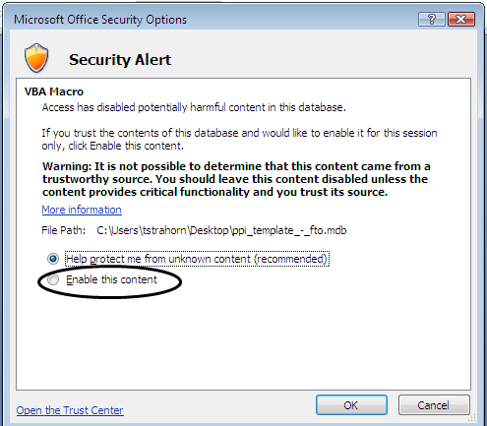
Figure 1: Security Alert Pop-up
Note:
- Files saved using Microsoft Office 2010 will have the “Enable Content” button on the “Security Warning” banner and therefore will not get a Security Alert pop-up.
- If a "read only" file is opened, in order to populate data in the file, click "Save As" in the "Read-Only" message bar. Enter the filename as the prime contractor + RFP number + file extension (e.g. XYZCompanyFA8201-18-R-0018.mdb).

- Select the radio button “Enable this content” and then click “OK.” A setup pop-up screen displays.
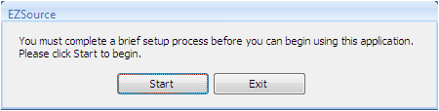
Figure 2: Setup Pop-Up
- Select the “Start” button. The “Application Setup” screen displays.
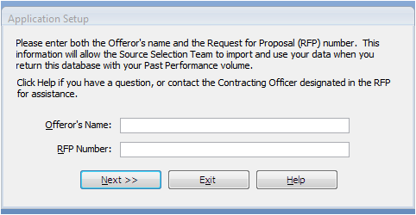
Figure 3: Application Setup Screen

- Enter the Offeror’s Name and RFP Number and then click the “Next” button. The application setup continues.
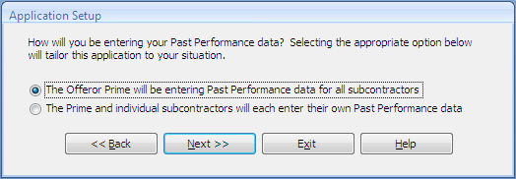
Figure 4: Continue the Application Setup

- Choose the appropriate option by selecting the corresponding radio button and then click the “Next” button. The “Contractor’s Menu” displays.
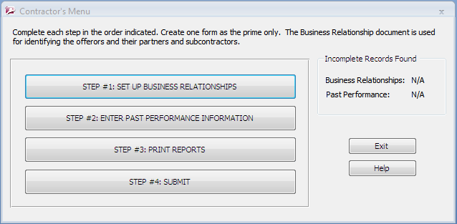
Figure 5: Contractor’s Menu
- Click the “Step 1: Set up Business Relationships” button to create a business relationship, if applicable, for each contributing contracting organization before proceeding throughout the PPI Tool (refer to Section L of the RFP for detailed instructions). Identify all prime and sub-prime organizations and categorize them according to the appropriate role in the proposed acquisition. The “Business Relationships” screen displays.
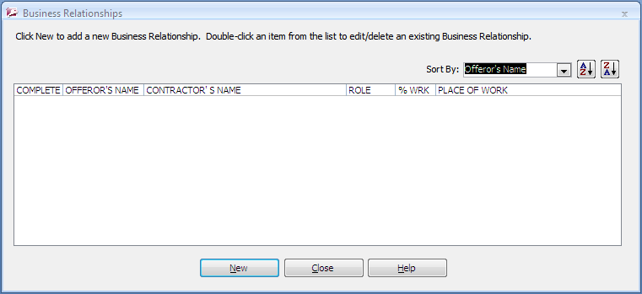
Figure 6: Business Relationships
- Click the “New” button to create a business relationship for the proposed acquisition. An additional “Business Relationships” screen displays.
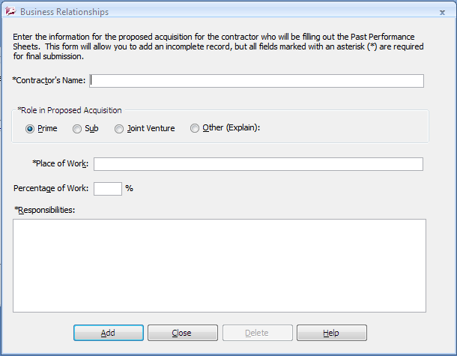
Figure 7: Enter New Business Relationship
- Complete the fields as follows (fields marked on the screen with an asterisk ‘*’ are required):
- Contractor’s Name: Self-explanatory
- Role in Proposed Acquisition: Choose one of the four options – Prime, Sub, Joint Venture, or Other (Explain). An explanation comment box will display when you select “Other.”
- Place of Work: Location where contractor will perform work.
- Percentage of Work: Identify percentage of work contributed by specified contracting organization.
- Responsibilities: Detail responsibilities of specified contracting organization.
- Select one of the buttons at the bottom of the screen.
- Add – Saves the current business relationship and allows for the addition of a new one.
- Close – Cancels the current business relationship without saving.
Note: In order to edit or delete an existing business relationship in the list, double-click on it.
- Select the “Close” button on the “Business Relationships” screen after all of the business relationships has been added.
- Click the “Step 2: Enter Past Performance Information (PPI)” buttonto enter the Past Performance Information. The “Past Performance” screen displays.
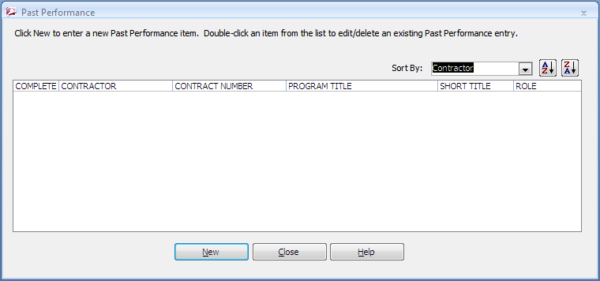
Figure 8: Past Performance
- Click the “New” button to enter Past Performance Information for the proposed acquisition. An additional “Past Performance” screen displays.
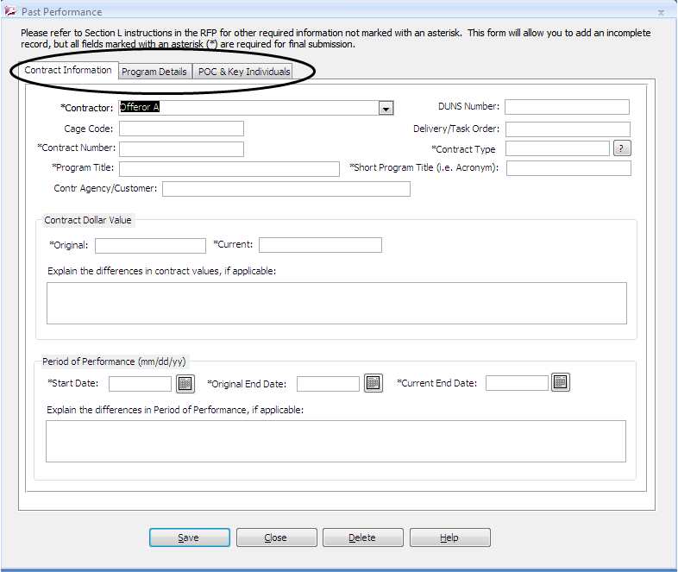
Figure 9: Enter Past Performance Information
- Complete the fields on each of the tabs as follows (fields on the screen marked with an asterisk ‘*’ are required):
- Contract Information Tab
- Contractor: Select from the dropdown the appropriate contractor.
- Cage Code: Self-explanatory.
- Contract Number: If you don’t have a contract number, enter “N/A.”
- Program Title: Enter full name of program.
- Contracting Agency/Customer: Enter servicing contracting agency and customer (office symbols suffice).
- DUNS Number: Self-explanatory
- Delivery Task/Order: If the order is provided as a stand-alone reference, enter the task/call/delivery/purchase order number.
- Contract Type: Enter Firm-Fixed-Price (FFP), Cost Plus Fixed-Fee (CPFF), Indefinite Delivery/Indefinite Quantity (ID/IQ), LH, Blanket Purchase Agreement (BPA), Cost Plus Incentive-Fee (CPIF), Cost Plus Award Fee (CPAF), etc. For additional clarification, click the question mark button.
- Short Program Title (i.e. Acronym): Enter abbreviated title for the program or enter “N/A.”
- Contract Dollar Value:
- Original: Input total contract dollar value, with all options if applicable, in the amount originally awarded on the referenced contract.
- If ID/IQ or BPA, provide total ceiling.
- If stand-alone task/call/delivery/purchase, provide amount of the individual contract.
- Current: Input total contract dollar value, with all options if applicable, as the contract stands at time of PPI submission.
- If ID/IQ or BPA, provide total ceiling.
- If stand-alone task/call/delivery/purchase, provide amount of the individual contract.
- Period of Performance (mm/dd/yy)
- Start Date: Input start date of contract.
- Original End Date: Input original end date based on award.
- Current End Date: Input end date, as the contract stands at time of PPI submission.
- Explain the differences in Period of Performance, if applicable: Enter an explanation of the difference between “Original End Date” and “Current End Date.”

- Program Details Tab
- Brief Description of Effort as:
- Select Prime, Sub, Joint Venture, or Other (Explain). An explanation comment box will display when you select “Other.”
- Provide a brief description of the service provided and actual work performed under this contract reference.
- ****If applicable: Provide information on problems encountered on the identified contracts. At a minimum, briefly describe the problem experienced, actions taken to alleviate the problem, and whether or not the problem was satisfactorily overcome.****
- Explain how your experience on this program is relevant for each subfactor under the Technical Factor in Section M of the RFP, including any unique aspects that demonstrate relevancy in this effort. Provide evidence to support how the contract referenced has relevant experience and demonstrates the ability to perform the solicitation requirements as described in Section M of the RFP. As applicable, address how the proposed reference relates to each of the Technical Subfactors.

- POC & Key Individuals Tab
- Customer Points of Contact: Click the “Program/Site Manager,” “Contracting Officer” or “Admin POC” button for the point of contact that you would like to add, edit, or delete.

Note: For government contracts provide current information on Program Manager, Contracting Officer, and Admin POC, if available.
- Select from the buttons at the bottom of the Past Performance screen:
- Save – Saves the Past Performance Information and displays the “Contract Information” tab on the Past Performance screen.
- Close – Closes the Past Performance screen. If there were any updates, a pop-up window displays asking to save before closing.
- Delete – Deletes the current PPI record. A pop-up window displays, select “Yes” to delete the record or “No” to close the window without deleting the record.

Note: In order to edit or delete an existing PPI record in the list, double-click on it.
- Select the “Close” button on the “Past Performance Information” screen after all of the PPI records have been added.

Printing Reports and Submitting PPI Tool
In order to print the Business Relationships and PPI reports, perform the following steps:
- Click the “Step 3: Print Report” button . A pop-up displays asking which report to print.
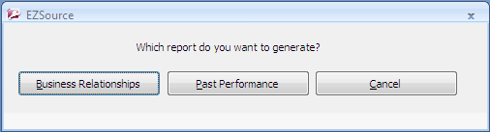
Figure 10: Select Report to Print

- Select separately each of the two options, “Business Relationships” or “Past Performance.” The Business Relationships and Past Performance documents will print separately; combine the two to create your Past Performance Volume.
In order to submit the Business Relationships and PPI, perform the following steps:
- Click the “Step 4: Submit” button . The “Submission Instructions” screen displays.
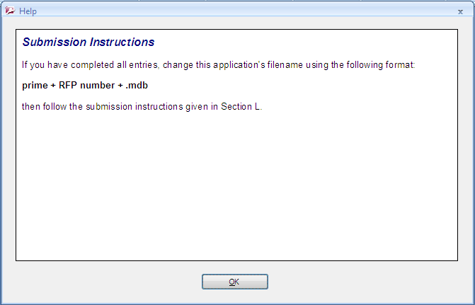
Figure 11: Submission Instructions
- Follow the submission instructions. Hard copies of the pages generated from this tool shall be used in the hard copy of the Past Performance Volume subject to the limitations outlined in this RFP and should be Tab 1 of the Past Performance Volume.

Note:
- Submit an electronic copy (e.g. CD) of the saved PPI database file with your proposal. Enter the filename as the prime contractor + RFP number + file extension (e.g. XYZCompanyFA8201-20-R-0018.mdb).
- Once the file is saved to a CD or any location that is marked as “Read-only,” it must first be saved to the desktop in order to read/edit the file.

Appendix B: Cross Reference Matrix
Subparagraphs may or may not apply. See specific instructions in the Section L paragraphs for details.
Cross Reference Matrix

 |  |  |  |  | Offeror’s Proposal Paragraph Number(s)
Section L | Section M | Sample Project SOW Paragraph | MACC IV SOW Paragraph | Vol

Appendix C: Example Project

Example Project Template
1. Example Project: Number example projects consecutively. If the contract was not direct with the end user, then the example project experience is not considered to be Prime Contractor Experience.
2. Contractor Name: Provide Name, Address, Point of Contact, Email, and Telephone number.
3. Contractor Basic Information: Provide contract number, title, location, award amount, award date, and completion date (completion date must be before MACC IV RFP proposal due date).
4. Project End User: Provide project owner or end user, such as a Government agency or installation, an institution, or corporation or private individual. Provide name, title, and telephone number (including area code) of an individual associated with the end user or the organization that contracted for the project, who is familiar with the project and the firm’s performance.
5. Description of the Project: Provide contract type (design-bid-build or design-build), physical size, and a brief description of the effort. Provide sufficient detail to establish the relevance to the proposed contract. Pictures may be provided but are not required.

Appendix D: Standard Form (SF) 330

