654123
MACC IV-23-1051198
Bldg 503 Mezzanine Contractor Questions
14 Dec 2022

- What is the load rating of the existing floor we are to replace the plywood on? Response: 200 PSF
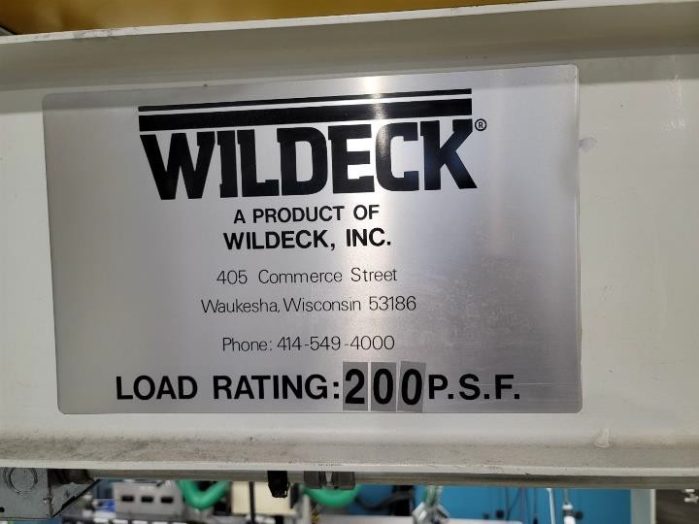

- What is the anticipated load with the new equipment configuration? Has any consideration to the weight of the new lather and hydraulic press on the existing floor?
Response: 200 PSF. Lathe and hydraulic press are already located on the mezzanine.

- How many workstations can be taken out of service at a time and/or are there areas that you can indicate that can be taken out of service to assist in planning the changeover?
Response: Negotiable, but work should be done in no fewer than three phases. Number of workstations affected will be dictated by the phasing of construction.

- Is it anticipated to need to have to add additional 208V panels to support the increased outlet count? Are there specific locations where transformers and panels can be added if needed? There are none shown in the concept layouts and Attachment 5 of the SOW is ambiguous on the number of outlets being added.
Response: Possible locations for transformer are outside next to MDP, inside south/adjacent to existing transformer, or possible wall mounted above existing transformer. Spare 225A in MDP.

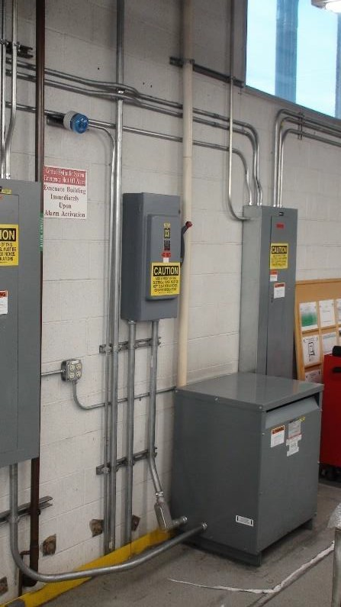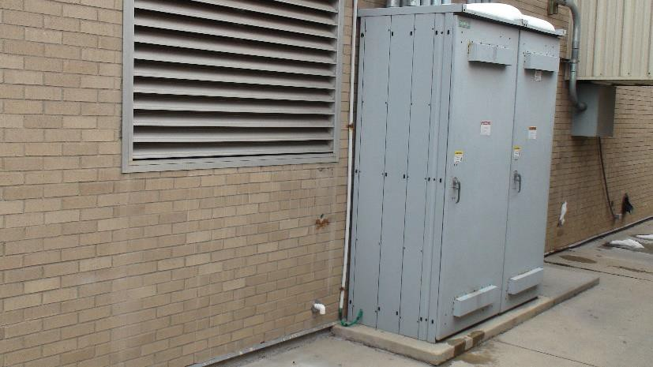
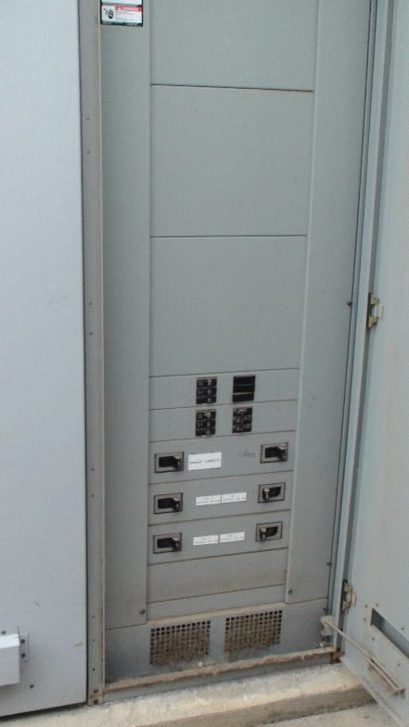
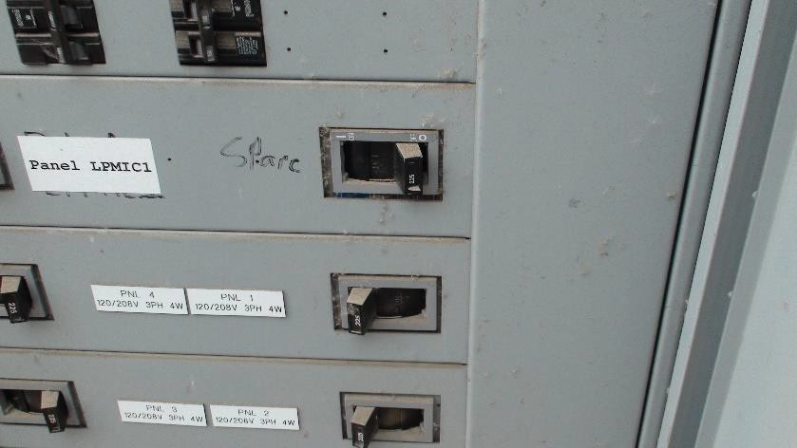

- Please provide model number for the existing electrical raceway we are required to match. Response: WIREMOLD (LEGRAND) ALA4800 Series Isoduct™ Aluminum Raceway, or approved equivalent. Electrical receptacles in lower channel, data connections in upper channel.

- Please indicate the areas that has the spongy plywood on the floor that are of concern. Is the plywood spongy from leaking on to it or heavy equipment on it?
Response: It is assumed to be degradation caused by rolling loads of cart and chairs, possibly dropped objects. Additional worn/spongy areas are expected to be discovered when all workbenches, cabinets, and equipment are moved.
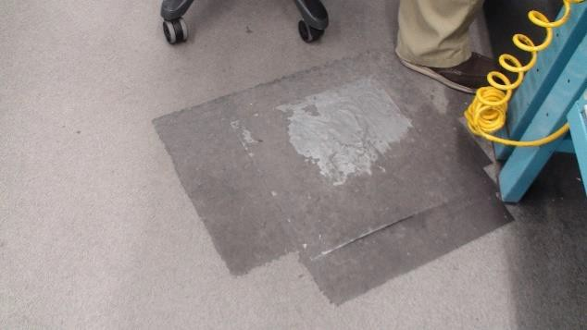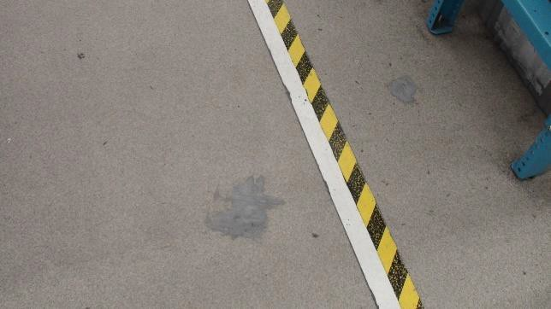

- Is it intended for the utilities to come up through the mezzanine floor or be dropped from above? If the utilities are to come up through the floor will the area under the entire mezzanine be available or will the work have to be staged like the mezzanine work?
Response: Primarily from above, where compressed air and electrical panels/circuits are already present. New electrical service for lighting may need to come through floor, which will need to be staged to minimize impact to production. Air sampling ports also need to come up through floor. Performing work under the mezzanine will need to be staged if it will cause outages for personnel and equipment.

- What is the existing lighting foot candles in the area where additional fixtures are stipulated in the SOW?
Response: Current lighting was tested, and ranges is between 65fc and 95fc. Target 85fc at workbench surface for new fixtures. Additional details available in UFC 3-530-01.

- Provide the details of cleaning, leveling, and refurbishing the existing floor as described in the SOW.
Response: This is what we are paying you to design. See question 53.

- Please provide the existing electrical load for the panels on the mezzanine. Response: See images below.

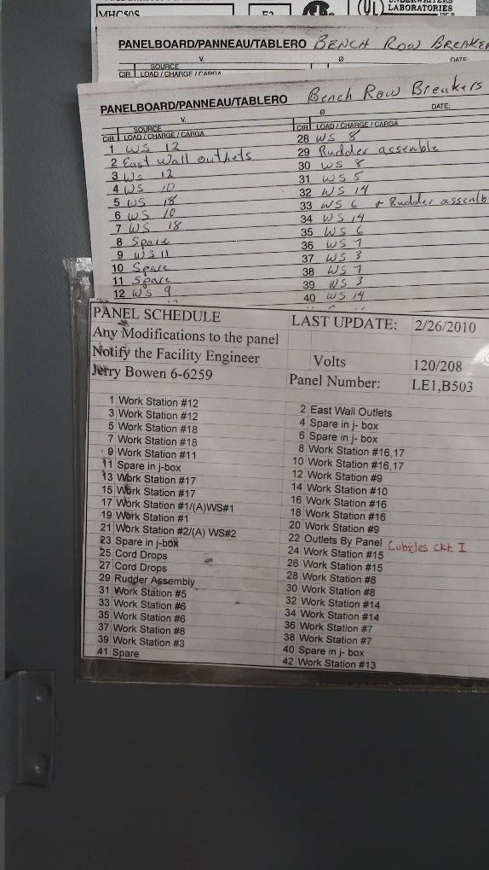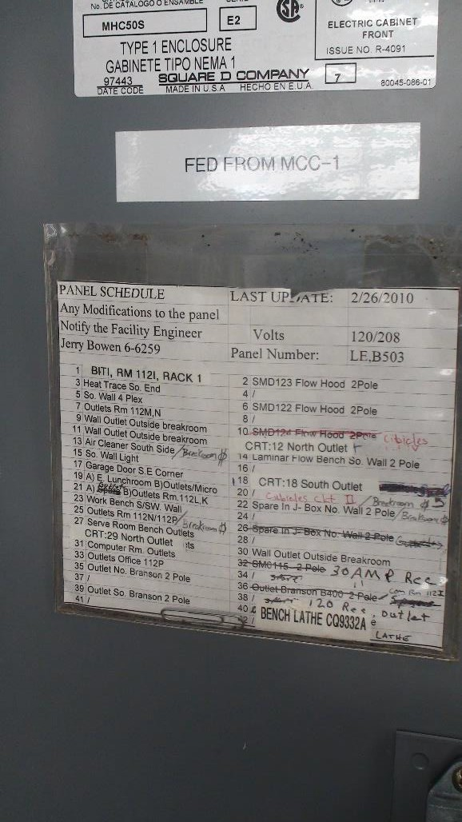

- What is the desired height of the stanchions?
Response: Bottom of wireway to be 4” above workbench tabletop, 40” AFF.

- What is the spacing of the stanchion supports for the raceways? Response: 60”

- Are stanchions made of Unistrut components acceptable?
Response: Yes, but the combined raceway/stanchion width not to exceed 8”.

- Untreated/unrated plywood flooring system on the existing mezzanine requires clarification. SOW mentions that if the flooring is removed and replaced, it is to be replaced with a fire rated ResinDek MD material. Is the existing plywood flooring is rated or treated in this way? Response: No information was found for the existing mezzanine. It is assumed to be standard plywood. Original manufacturer is WILDECK, Inc. No job number was found on mezzanine, so WILDECK was unable to give us specifics. No records were found at Hill AFB related to mezzanine installation.

- With the due date for questions being 14-DEC-2022 the government will need at least one week to properly answer questions (if not more). The responses would then be sent to bidding contractors via amendment right before Christmas with proposals needing to be organized over

the Christmas holiday weekend and then submitted back to the government to make the 28- DEC-2022 due date. Bidding contractors need about three weeks to receive the government’s responses, incorporate them into the designs and make corrections, send the new design corrections and Q&A out to subcontractors and then give them a few days in order to do corrections on their end and get a price back to us. As the upcoming holidays are during the current bid time, would the government consider extending the bid date to allow for three weeks from the date the last response is posted from the government and allow needed time that is not overlapping the upcoming holidays?
Response: The FOPR DUE DATE WILL BE EXTENDED TO MID/LATE JAN 23.

- The existing fire suppression system was installed in 1992, on past jobs CE Fire Department and Fire Suppression Shops have required to have the sprinkler lines Flushed and Camera 50% of the lines in the work area. Is this going to be included in this SOW?
Response: Per UFC 3-601-02, only sprinkler systems that are 50 years old with standard response sprinkler heads need to be tested, flushed, and scoped with camera. For systems 20 years old, all sprinkler heads need to be replaced if they are quick response. Otherwise, they can remain.

- With the sprinkler heads on this system dated 1992, does the Government wish to have the sprinklers replaced over the work area?
Response: No, not unless the fire suppression layout needs to be changed to satisfy NFPA requirements, or replace if they are quick response sprinklers.

- With new offices being installed on the north end does the Government wish to have new sprinklers installed in them?
Response: No new offices will be installed, only refurbishments to walls, ceilings, and floors. Update sprinklers and layout according to NFPA, or replace if they are quick response sprinklers.

- How do you want us to Bid the AHU? We were unable to see it on the walk. Does the Govt. know what the issues are? With the holidays we might not be able to get a tech to look at it for a service quote. Are we replacing heating and cooling coils? If repairing, how long does the unit need to stay functional for? Are we to repair by replacement? What is the Make and Model of this unit?
Response: Cooling coil is assumed to be the primary issue, as reported by occupants. Please contact Matthew Larsen at 801-586-1535 to coordinate visit to inspect, if desired. Standard one
(1) year functionality by means of warranty on parts/labor. Repair by replacement is acceptable, but Government reserves right to approve the equipment selection. The existing model is a York ZQE06A4B1AA1A111A2 (6-ton, cooling only)

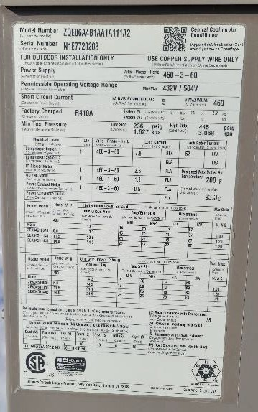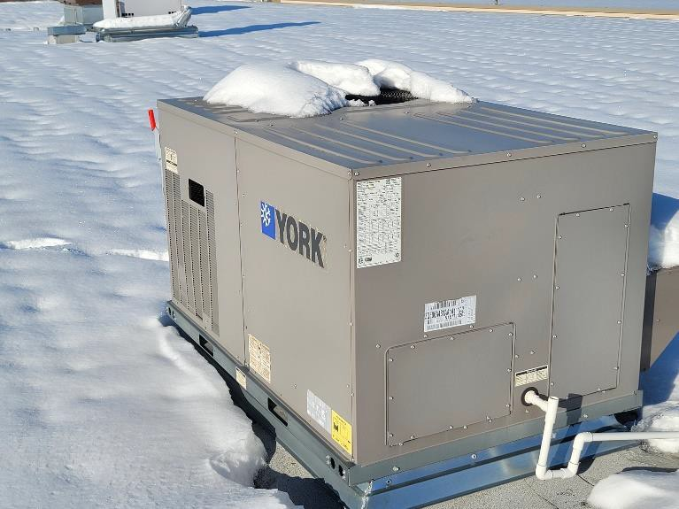

- Can we get more information about where the Compressed Air drops will be required? The Equipment Excel sheet says we need 33 Bench Air Receptacles, but the drawing doesn’t indicate where. Will the Compressed Air Branch lines be replaced in the ceiling as well? Does the 3” loop need to be changed from black steel pipe to Copper?
Response: I believe 33 is just for one of the “shops” in the future layout. All workbenches and the parts washer (X5) will need air quick connections. These connections should tee off from lines mounted to the wireway stanchions and be mounted under the workbench with pipe straps so the quick connections are easily accessible by technicians. The 3” loop does not need to be changed. Replacing the lines in the ceiling may be required to provide adequate air to all workbenches, and to provide an organized and tidy compressed air distribution system. Ensure dielectric unions are used when connecting dissimilar metals (copper to steel, etc.).

- The SOW section 2.17.10 states that we are to “repair AHU to working order.” There is no other information that details what is needing to be repaired or why the AHU is not currently functioning. Bidding contractors will need more information as well as more time to assess. Can we get and extension on the Bid date so we can have a service rep come out to look at the AHU?
Response: See Question# 19 and Question #15

- For the new workstations. A question I would ask would be to confirm how much air we are to replace.
Response: All drops for the workbenches will need to be replaced as the layout will change completely. Modify the overhead air lines as needed to ensure all workbenches are supplied with 100psi air. Regulators should be accessible for maintenance and adjustment without needing to move furniture/equipment or using ladders.

- The SOW section 2.27 says that we are to work on only one section at a time and that a section is defined as from “concrete column to concrete column.” Would the government please provide pictures from many available angles to show these section areas?
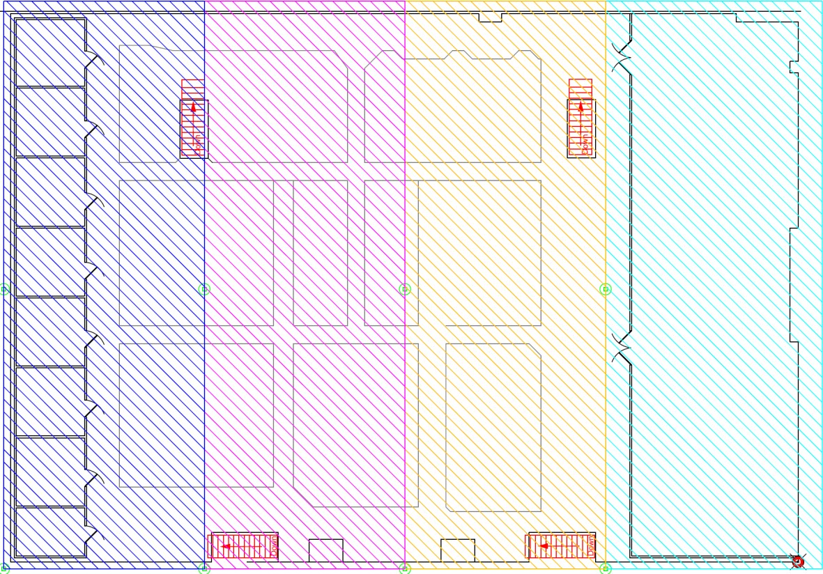
Response: Here is one example of how to phase this project, between concrete columns. However, other phasing proposals may be considered as all utilities will be affected during construction. The aim is to disrupt bench work as little as possible during construction so the Air Force can continue to meet their production commitments.

- Would the government please provide pictures of the mezzanine deck from down below showing the deck, screws, supports, etc.
Response: See below

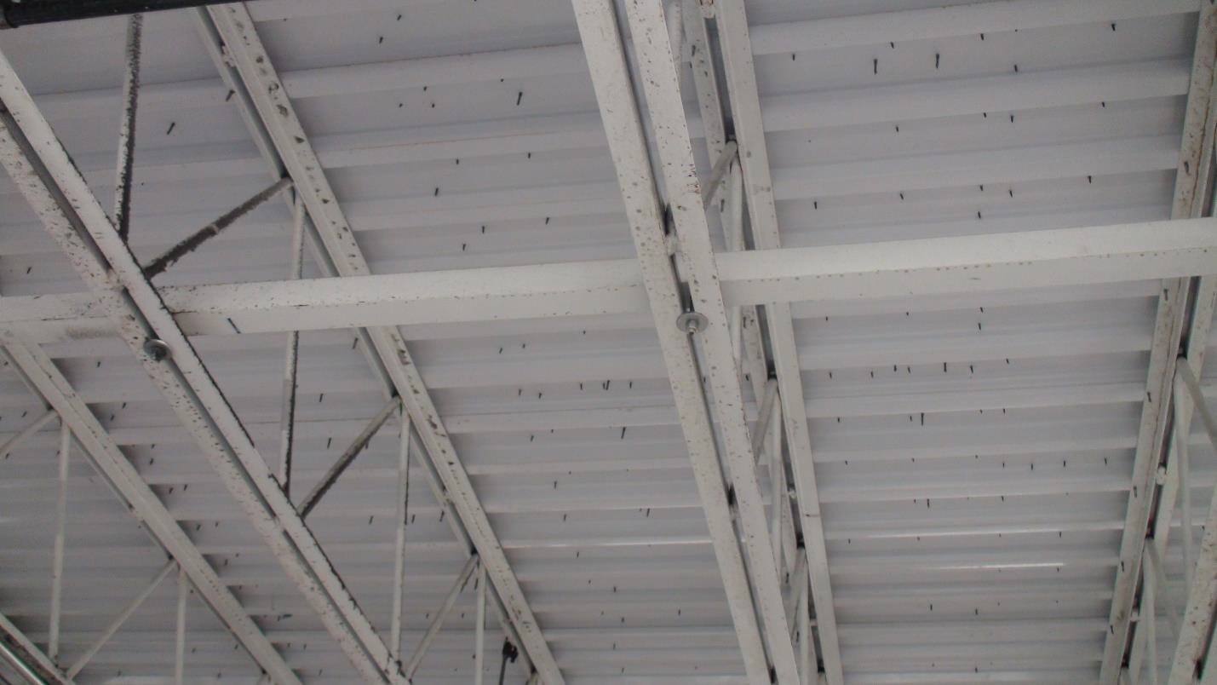
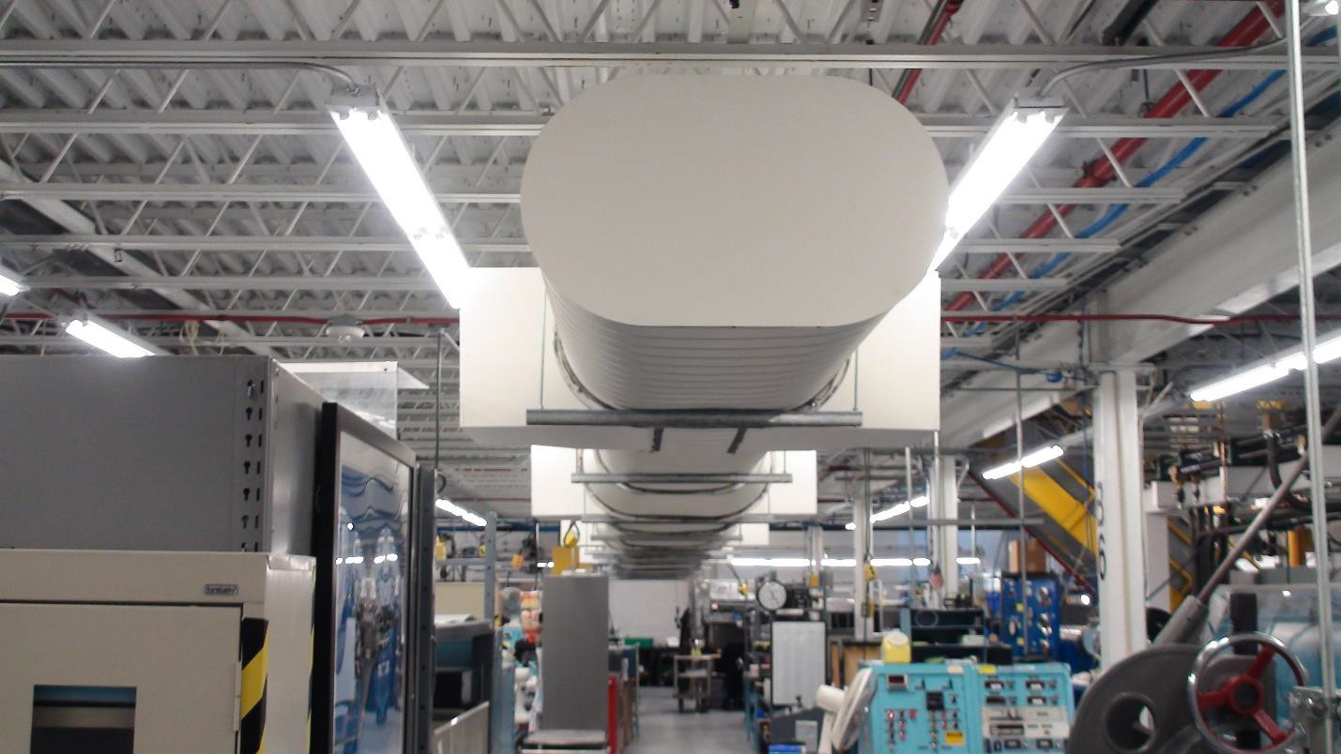

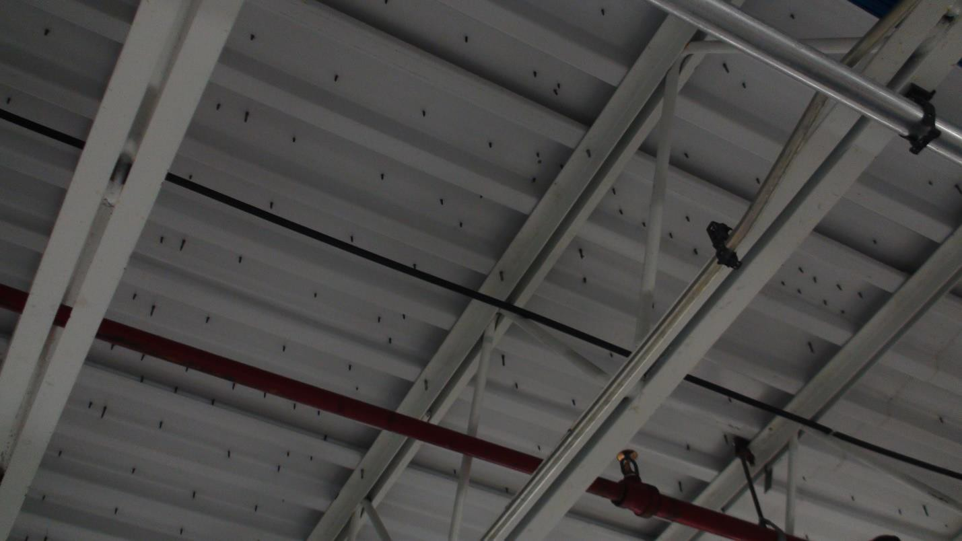
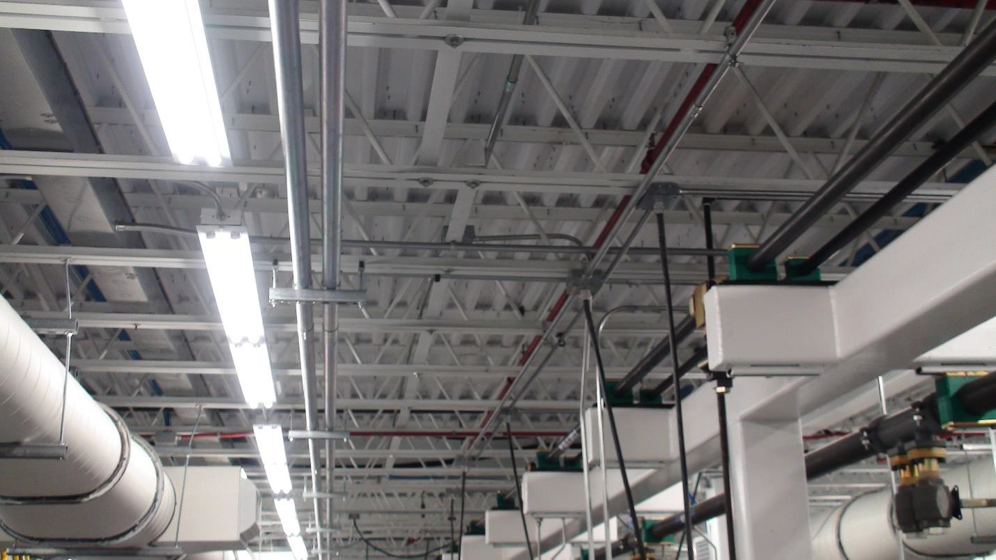

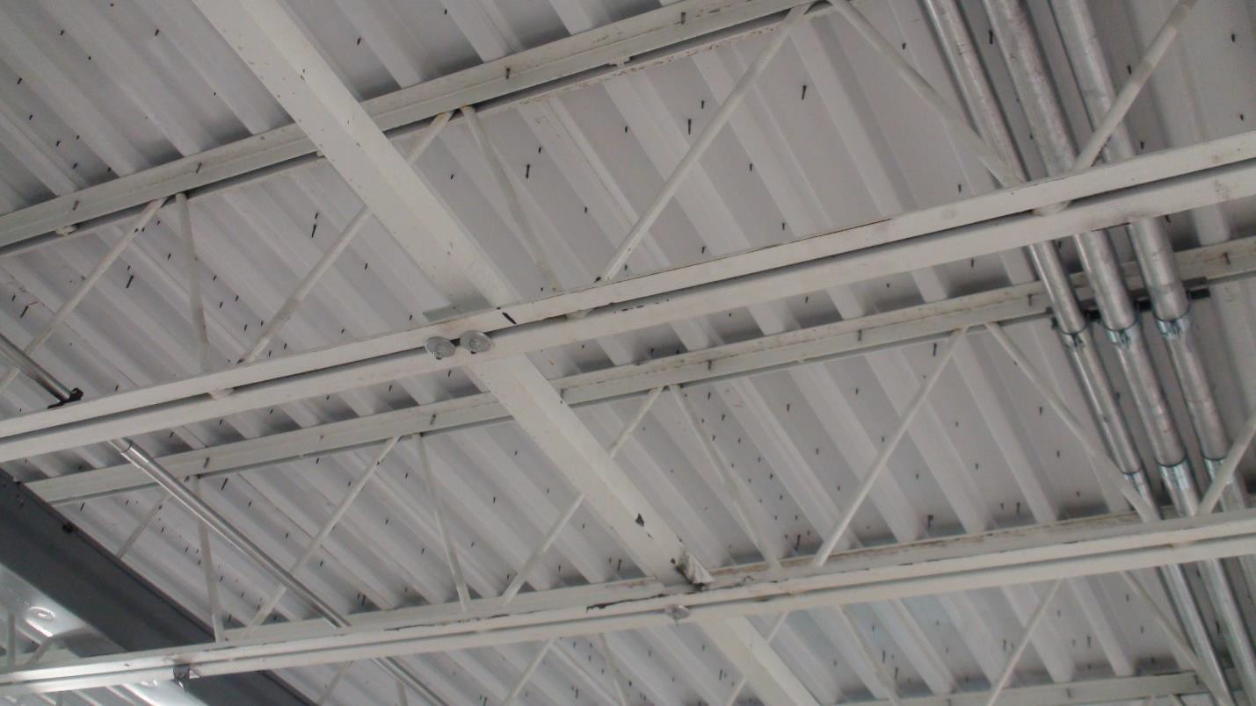
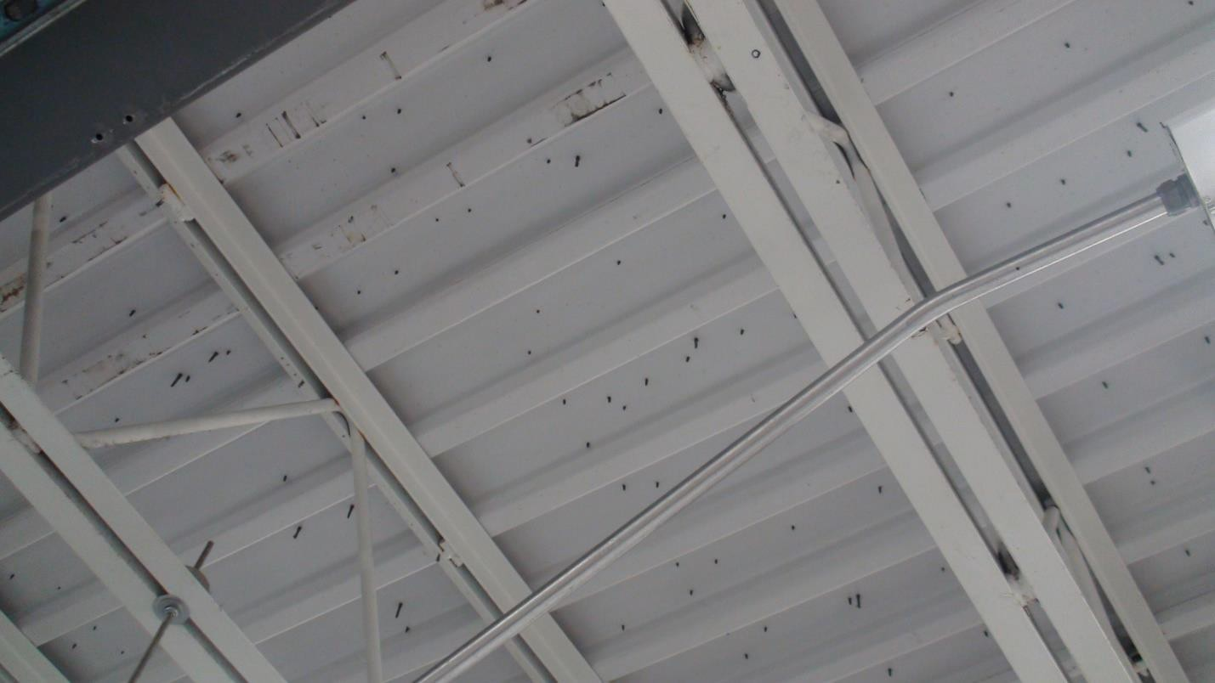

- Would the government please provide pictures of the areas below the mezzanine that we are required to cover and protect per SOW section 2.27?

Response: See below for general idea of equipment below mezzanine:
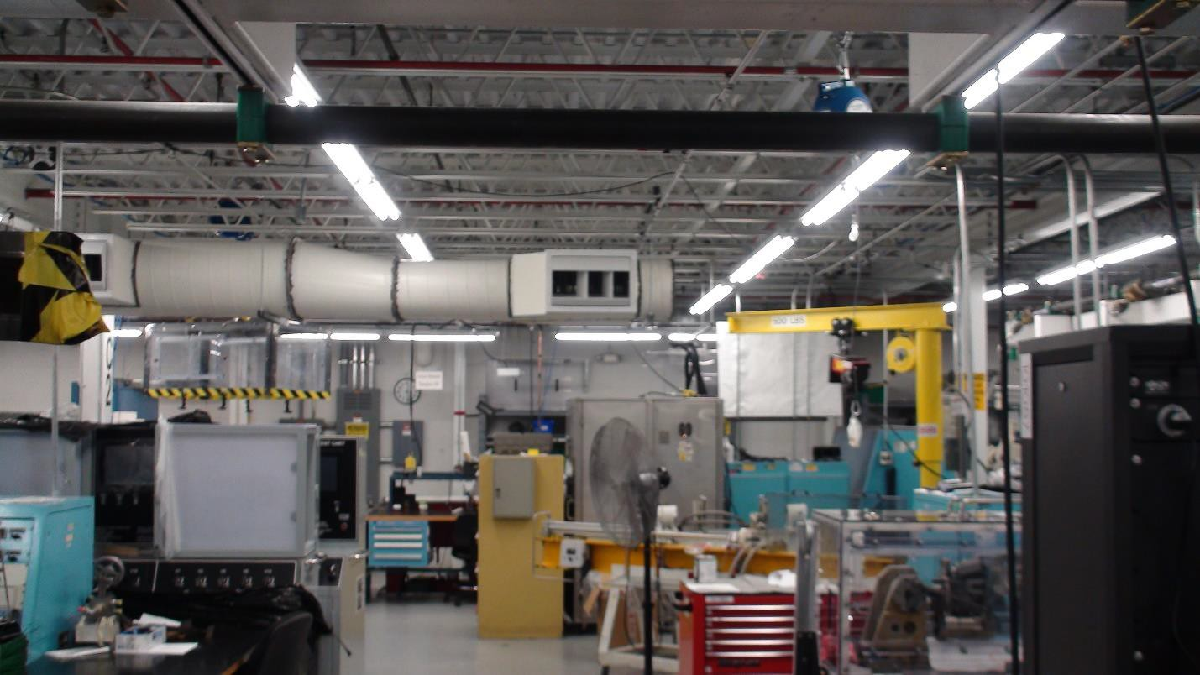
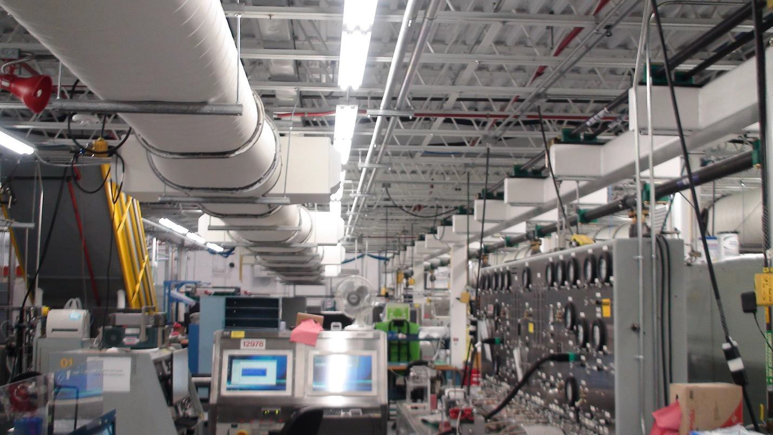

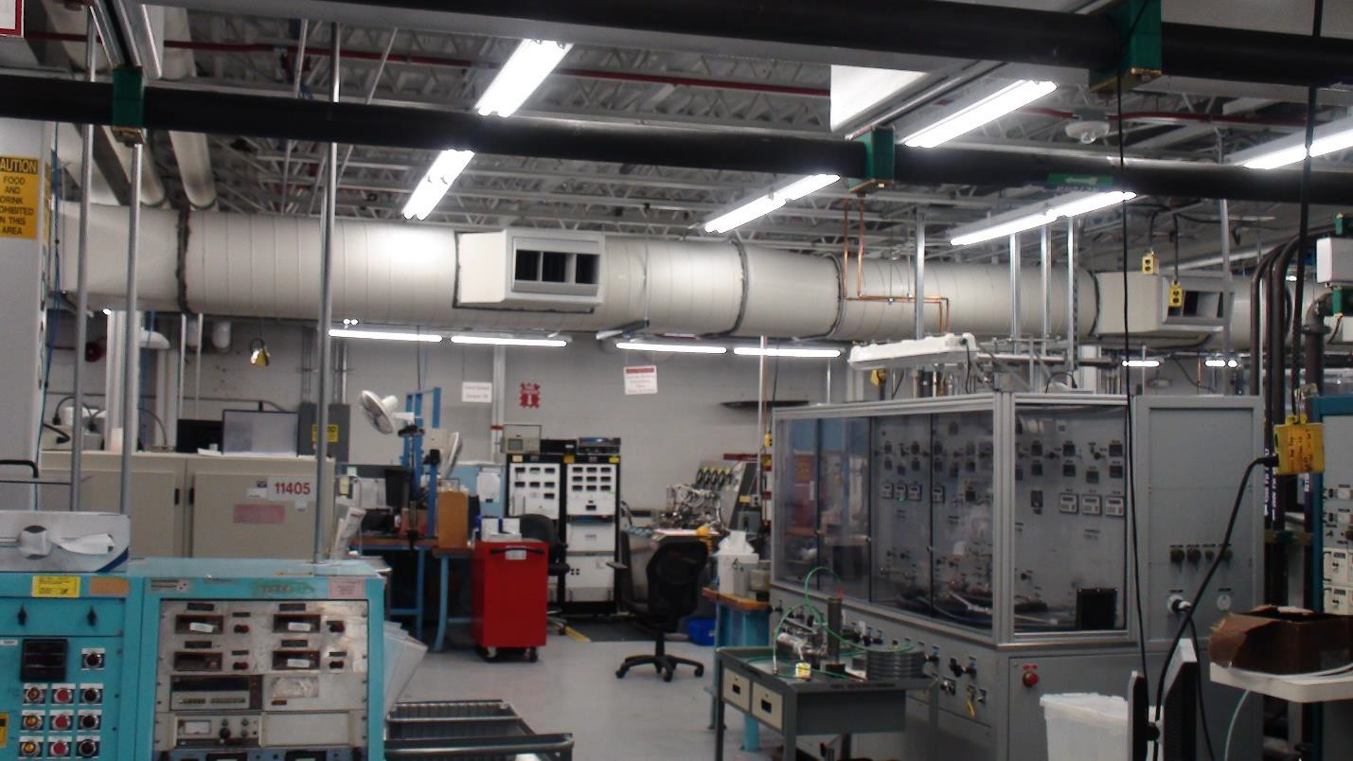

- SOW section 2.27 states that a section is measured approximately at 35 feet in length from concrete column to concrete column. What is the approximate width of a section? Response: Approximately 96’

- SOW section 2.24 states that the “approximate number of people occupying the space” is 143. Is that approximate total before the renovation of this project or after once more space is added?
Response: After the renovation of the mezzanine, not including the supervisor offices, which would bring the total to approximately 150.

- SOW section 2.14 states that “no changes or modifications are required to be made to the existing HVAC systems, except for the private offices on the north end of the mezzanine.”
During the site walk, the government representative mentioned the HVAC system on the mezzanine as being replaced. Please confirm that the only HVAC scope is per the SOW and any other existing ducting, vents, etc. for the HVAC on the mezzanine open area and old breakroom area are not being touched, adjusted, or modified?
Response: A separate project recently replaced the HVAC system that supplies air under the mezzanine. However, only the repair of the RTU supplying the supervisor offices located on the north end of the mezzanine, and relocated some thermostats located on the “break room” wall that will be demolished, are included in the scope of this project.

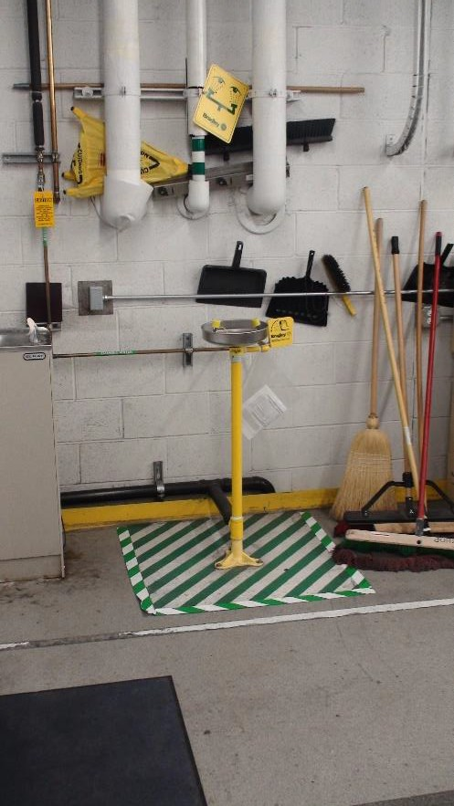
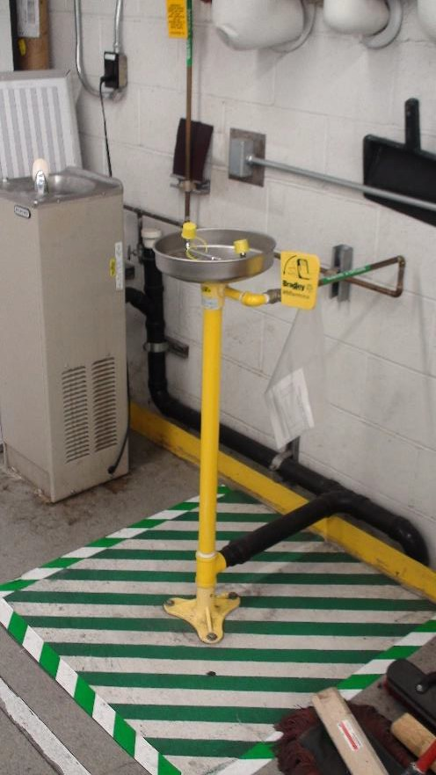
- Per the SOW section 2.23 there are two existing eye wash stations along the east wall that are remaining. Please provide pictures. Are those mounted to the wall or to the floor, and will they need to be temporarily removed and salvaged to do the floor work for that section/area? Response: They are mounted to the floor. Yes, they will need to be temporarily removed while floor is repaired, then reinstalled.

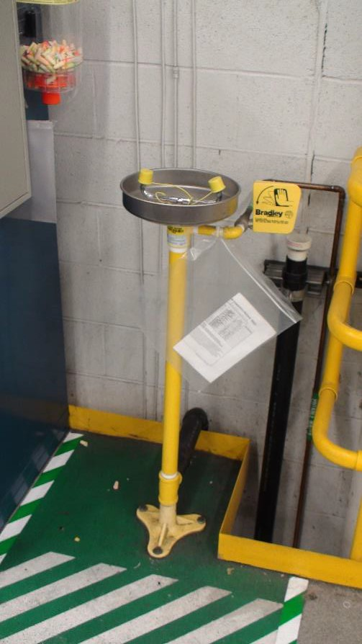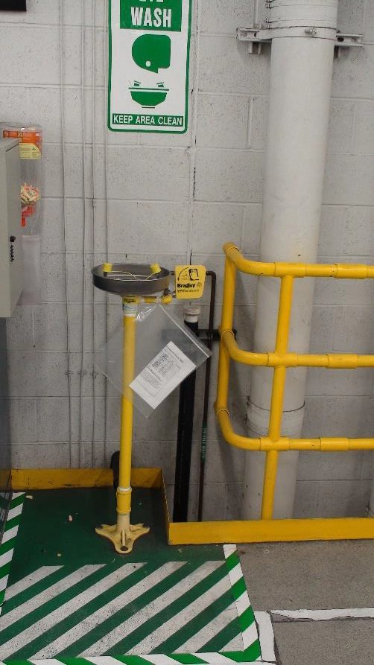

- SOW page 5, section 2.17.6 says to “provide new carpet tile 18” x 18” typical” and that we are to match B503A. Will the government please provide pictures from building 503A that show the carpet we are intended to match?
Response: Please contact Jeff at FLOOR STYLES, INC. for details - (801) 281-4747. Records show
carpet is called “Wine and Honey”, by Milliken, but may have been a custom color for USAF.
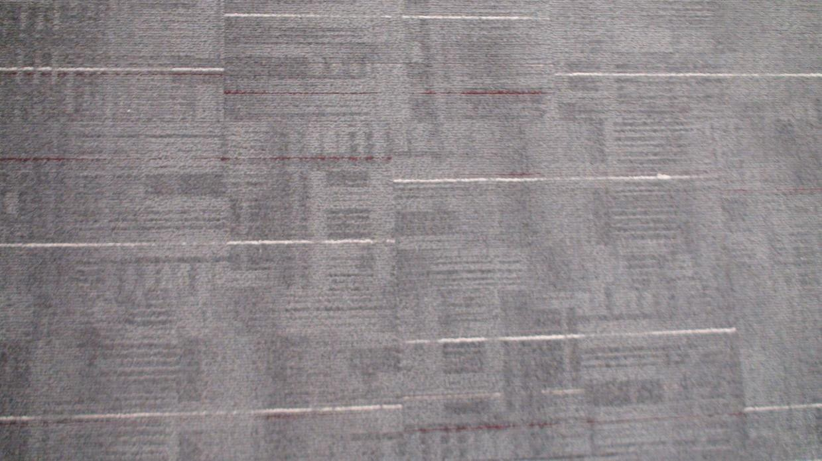

- SOW page 6 says we are to supply Milliken carpet tiles per the Air Force BPA. Will the government please provide more information as in pile thickness, color scheme/choice, matt/weave type, etc.?
Response: Match carpet pictured in question 30

- What is the desired wall base material for the private offices once the carpet is installed? Response: Gray vinyl cove base, 4”

- SOW page 6 says that the “laydown area for the contractor shall be identified at the site walk.” This did not occur, but the government did provide attachment #6 which is a 503A staging map that was sent out with the bid documents. Is this the same document?
Response: Yes, staging area is as depicted in attachment 6.

- With the flooring being removed in its entirety we are to assume that the plywood flooring is also underneath the private offices. Is that flooring intended to be removed as well or just simply the carpet tiles as it states in SOW section 2.17.1?
Response: Just carpet tiles is sufficient unless the transition/threshold between the offices and mezzanine shop flooring creates a tripping hazard.

- If only the carpet tiles are being removed and the main plywood flooring is remaining underneath the private offices, how is the government intending on having the contractors remove the wood flooring up to the walls of the private offices without causing undo damage to the outside office walls, metal deck underneath, etc.?
Response: By being careful and repairing any undo damage that occurs.

- Per the SOW page 7, asbestos and LBP is not anticipated for this project and the hazmat report as well as a process for handling has been provided. Please confirm that if asbestos or LBP is encountered during the project it will be a change order to the government?
Response: Confirmed.

- It is our understanding that the 503 Mezzanine area is currently classified as a “Class 300,000 Clean Area”, which is accommodated by the existing HVAC system and several additional Filter Fan Units. Can the existing HVAC and Ventilation systems still meet this requirement with the additional square footage being added to the mezzanine work area?
Response: This has not been confirmed, but the “breakroom” area of the mezzanine was originally part of the “Class 300,000 Clean Area”.

- Please provide pictures of the panel schedules for all panels feeding into the area. Response: See question 10

- Please provide locations in the rows for how work booths are currently being fed, with circuitry if possible. Home Run Locations.
Response: All benches are fed by panel LE1, in groups of ~4 workbenches. A few pieces of equipment are fed by panel LE. See below for additional detail. Contractor should field verify for any receptacles/equipment not listed below, or consult the panel schedules in question 10.
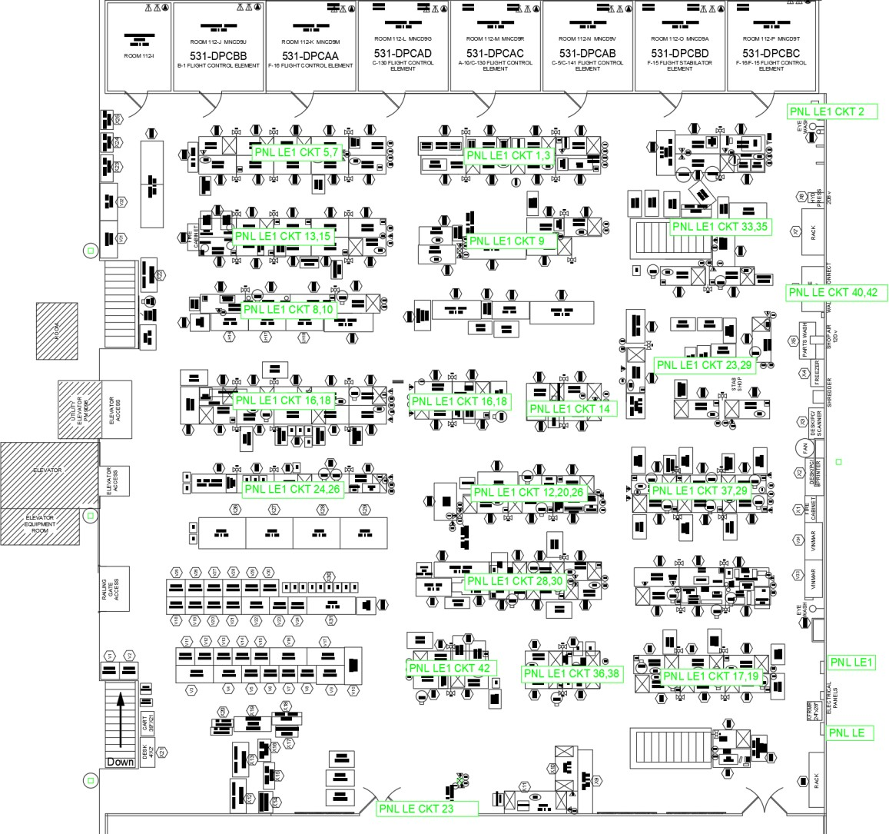

- It appears that lighting in the work area has been retrofitted from florescent to LED, the RFP stated to match existing fixtures with any new ones which will need to be ordered. Please provide what the existing fixtures are so that we can find out if they are available. If it is deemed that the current fixtures are not a viable option, how much leeway will the government grant for any new fixtures needed to fill the work area space properly?
Response: The existing fixtures are part of a 20-year energy contract through ESG and Hill AFB Civil Engineering. New fixtures may need to be added to provide sufficient lighting, which will need to meet the following criteria: Per Hill AFB UFC, new LED fixtures must have 10-year

warranty; new fixtures must match the brightness and temperature of existing lights (field verified by contractor). This may be done through careful selection, or by means of fixtures with adjustable warm/cool LEDs and dimmer. New fixtures should be grouped together, rather than dispersed among old, retrofitted fixtures.

- As the existing fixture layout will change nearly completely, please provide locations of the home runs for each row of existing fixtures, and the circuits if possible.
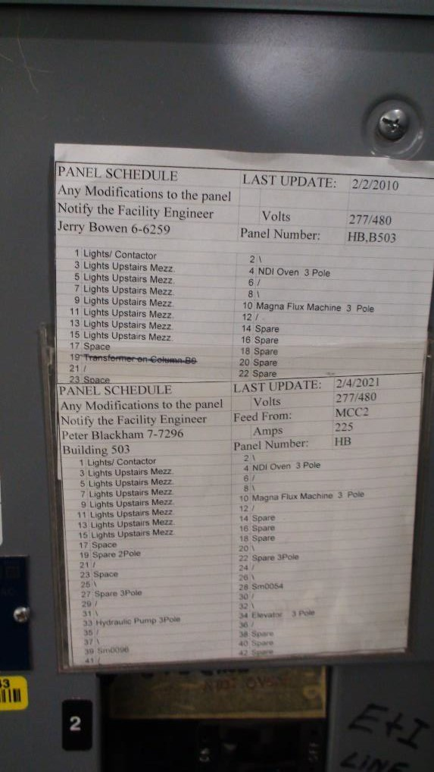
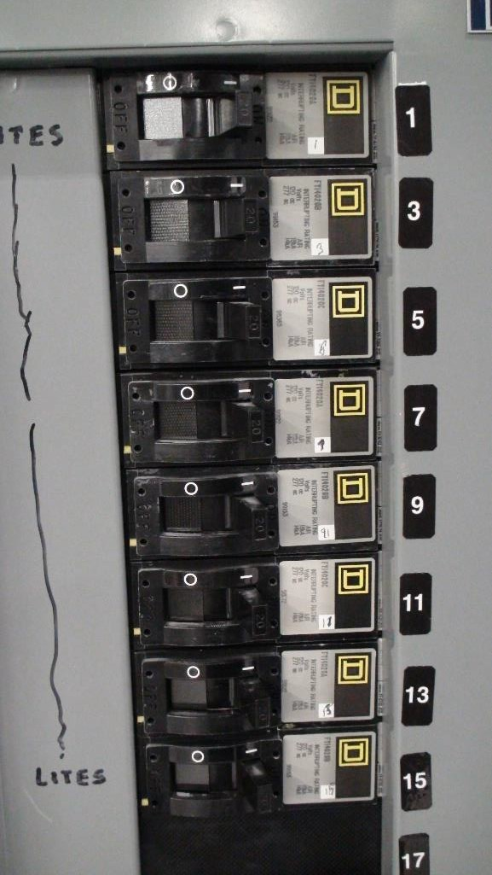
Response: Lighting fixtures are fed from panel HB. See below for panel schedule, pictures of circuits, and available spares in panel.

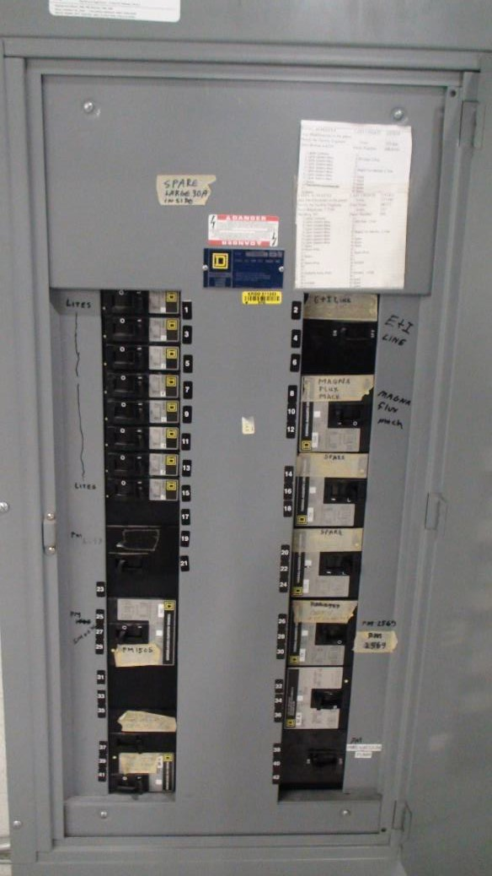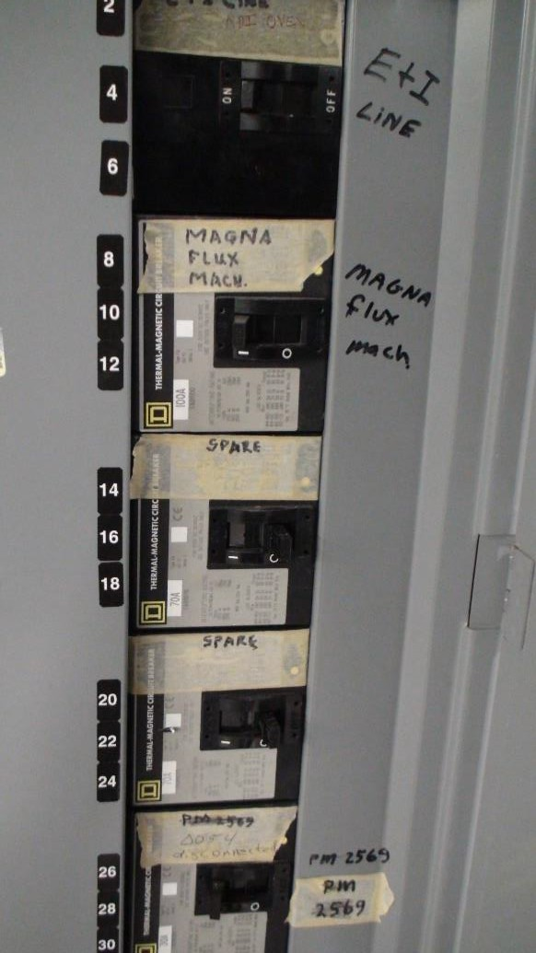

- Please provide a VA load rating for each workstation for circuiting purposes. How many booths can we put on a circuit?
Response: Preferably two 120V 1Ph 60Hz duplex receptacles for every workbench, but four duplex receptacles per circuit. Workstations/equipment will connect to receptacles on wireway, as opposed to receptacles built into workbenches.

New transformer and panel will be required. Suggest wall mounting transformer above existing transformer, see question 4 for images depicting MDP and existing transformer.

- Are any dedicated high-power booths or outlets required in the work area? IG. 208V 3P 30A, 240V 1P 50A, etc. If yes, please state how many of what kind the government would like, and in what general vicinity.
Response: Yes, a lathe and hydraulic press. Both already have circuits in panel LE. See question 4 for picture of panel schedule.

- If additional panels are required to meet the circuiting needs for the work area, please define governments preferred sources for power, and what provisions will need to be provided to feed new equipment. Where are the panels, we would be coming out of located? What is the voltage and the available current on said panels?
Response: Locate new panel adjacent to panel LE and LE1 (see question 4 for picture). Spare 225A 480V located in MDP East Center.
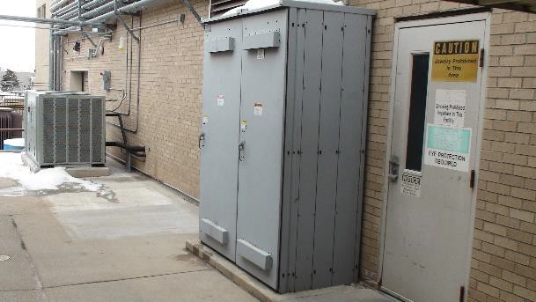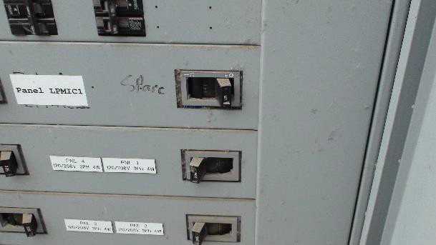

- Fire Suppression- If Sprinklers get changed, would the GOV like to also have the lines flushed?
Response: See question 16

- Please provide photos for:

  - Wall to be demolished
  - Acoustical Ceiling in offices
  - Mechanical unit on roof –
  - Underside of mezzanine deck showing screws
  - Equipment that needs to be moved and relocated by the contractor Response:
A: North and West walls of breakroom being demolished
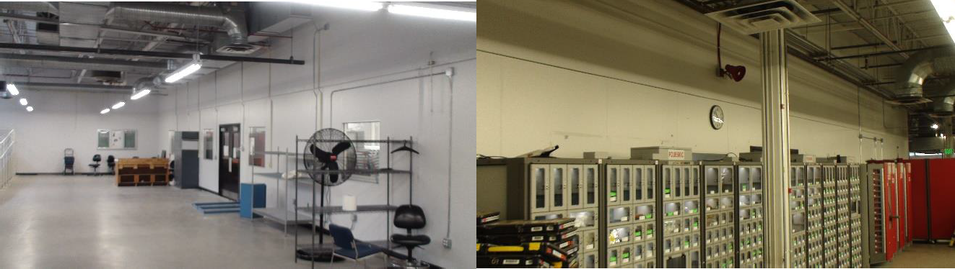

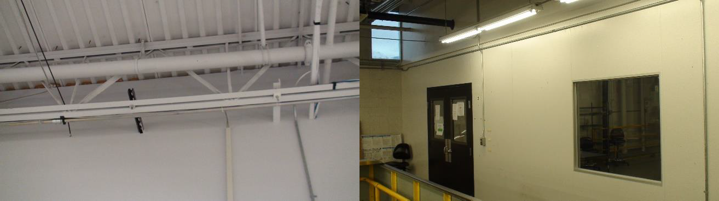

B: Acoustic tiles in private offices
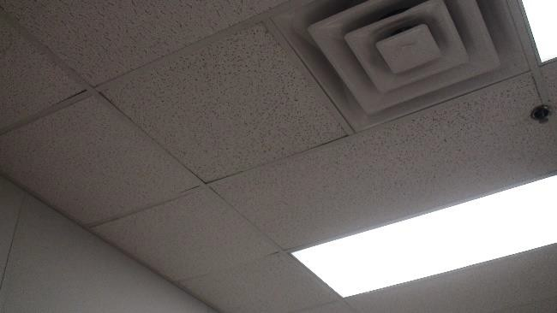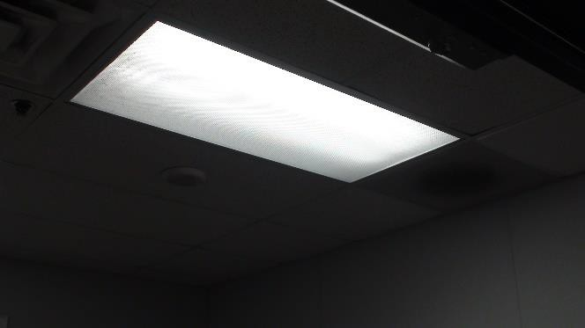

C: See question 19 D: See question 24
E: All equipment to be moved by contractor
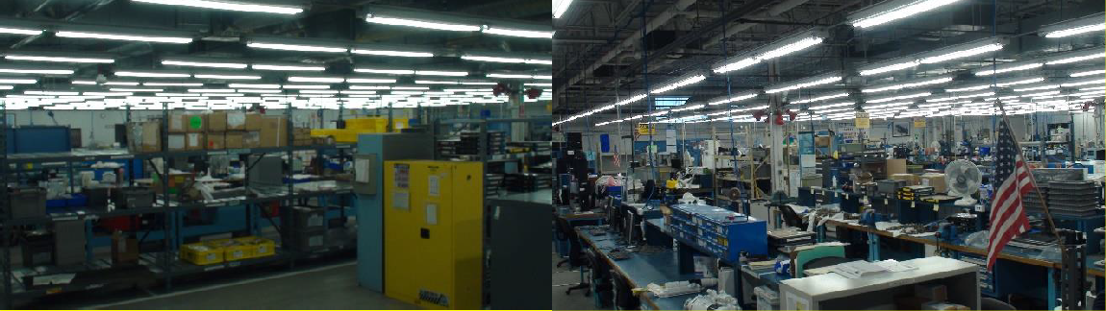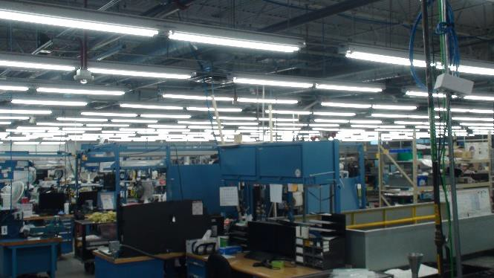

- Please provide information on the mechanical unit on the roof. Is it working? If not what is not working? What size is it? Manufacturer? How old is it?
Response: See question 19.

- The SOW discusses the need for this to meet ADA requirements. There is already an elevator to access the mezzanine. Are there any other ADA requirements needed other than clear paths between workstations? Is this a blanket statement or is there a specific need we are to address? Response: Just clear paths between workbenches/workstations.

- Please provide a list of equipment that needs to be numbered and will be stored and relocated to a new location.
Response: All workbenches and equipment has been numbered by Dennis Eager on the provided layout drawing. Contractor is free to use alternative numbering system.

- Please clarify the phasing for this project the phasing in the SOW is not very clear.
Response: Phasing is up for discussion, but the Squadron needs to maintain as much capacity as possible during construction. Limited swing space is available in building 503A Room 101, but not enough for every workbench on the mezzanine. Likewise, the test stands and equipment below the mezzanine cannot be relocated during construction, so minimizing downtime is one of the priorities of the constructions schedule. Suggest working in sections in the north-south direction, defined by the space between columns. However, government will consider alternative proposals for phasing construction by contractor.

- Please provide clarifications for electrical and low voltage. Where are the source locations and where will be get new from?
Response: MDP East Center has a spare 225A circuit. An outdoor transformer can be installed adjacent to MDP, or a transformer can be mounted to wall above existing transformer and fed to new panel.

- Are there as built drawings for the mezzanine structure? Response: No, not that I’ve been able to locate.

- SOW 2.9.1 – Please clarify if we are to remove the floor or not. Determination of this may not happen until after award. Or is this just referring to something else. Are we to put a new floor system over the existing floor?? Please clarify.
Response: Replace, if possible, all flooring panels, except those under the supervisor offices on the north end of the mezzanine, and those under the ramp on the south end of the mezzanine. Ensure no fasteners or debris interferes with equipment, utilities, or personnel below the mezzanine by means of rigorous visqueen/plastic containment over and around all furniture and equipment below. Ensure all hydraulic valves, electrical junction boxes, electrical panels, and other sensitive components are protected from debris and vibration during construction. No
discontinuity between flooring panels can exceed 0.0625”. Ensure consistent tread height of top stair tread with other stair tread heights. Countersink all fasteners. Epoxy coat the new flooring with low-gloss medium gray epoxy and aluminum oxide anti-skid abrasive. Color and broadcast selection to be reviewed and approved by Government POC.

Present alternative proposal for repair if replacement is not possible but give detailed explanation why not replacement is not possible. Repairs to include a minimum of 50 3”x3” patches, 30 6”x6” patches, and 10 12”x12” patches, up to 20 L.F. around stairways, material lifts, columns, or mezzanine edges. Level any discontinuity in the floor exceeding 0.125”. Re-epoxy coat entire mezzanine floor as part of repair with low-gloss medium gray epoxy and aluminum oxide non-skid abrasive. Color and broadcast selection to be reviewed and approved by Government POC. Any additional repairs required beyond what is detailed above will necessitate a mod to the contract.

- Please confirm the flooring in the office areas will not be removed.
Response: Carpet will be replaced. I don’t believe replacing the plywood decking will be
possible without dismantling the offices.

- SOW 2.10 – is 3500PSI per cart with 4 wheels or is that per wheel. Response: Per wheel.

- Is the metal decking 20 ga or 18 ga? Response: Unknown

- What is the design load of the existing mezzanine? Response: 200 PSF
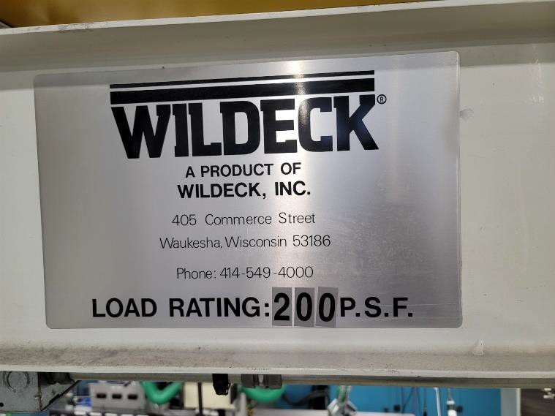

- What are the loads the carts carry over this floor system? Response: Variable, and subject to change with new workloads.

- How do you want us to Bid the AHU? We were unable to see it on the walk. Does the Govt. know what the issues are? With the holidays we might not be able to get a tech to look at it for a service quote. Are we replacing heating and cooling coils?
Response: See question 19.

- If repairing, how long does the unit need to stay functional for?

Response: See question 19.

- Are we to repair by replacement?
Response: Repair by replacement is acceptable. See question 19.

- What is the Make and Model of this unit? Response: See question 19.

- Can we get more information about where the Compressed Air drops will be required? The Equipment Excel sheet says we need 33 Bench Air Receptacles, but the drawing doesn’t indicate where. Will the Compressed Air Branch lines be replaced in the ceiling as well? Does the 3” loop need to be changed from black steel pipe to Copper?
Response: See question 20.

- Can we get and extension on the Bid date so we can have a service rep come out to look at the AHU?
Response: See question 15.

- The SOW isn’t firm as to whether the floor system will be removed or not. Please clarify if this is to be removed or leave it.
Response: See question 53.

- The floor system seems to be in good shape. Is the government open to repairing the areas that are worn out and leaving the rest?
Response: Yes, if replacing the existing floor is not feasible. See question 53.

- SOW 2.9, 2.9.1 – Calls for the complete removal of the plywood, epoxy and associate fasteners and Attachment 001 shows the extent of the removal to cover the entire mezzanine. Removal of the flooring system in the area at the north end of the mezzanine with existing office walls will necessitate the removal of the existing office walls built on top of the existing flooring which is not currently in the scope of work. Would it be acceptable to remove the existing floor system up to the office walls and leave the existing flooring under the office walls in place?
Response: Yes.

- SOW 2.9.1, 2.10 – Are the requirements of 3500 psi rolling loads with no vehicle cart impressions still applicable if the floor is refurbished and not replaced?
Response: Yes.

- Based on the SOW and the information provided at the site visit, it is apparent that there are concerns about the mezzanine deck being able to withstand the removal of the old flooring materials and the installation of a new floor. Will the government please provide as-builts for building 503 detailing the mezzanine?
Response: See question 52 and question 53.

- Per the SOW paragraph 2.9 and 2.9.1, “Existing floor of the mezzanine is believed to be epoxy coated ¾” plywood over metal decking. The plywood, epoxy, and associated fasteners are
required to be removed in the entirety by the contractor…If complete removal is deemed unfeasible, the existing floor shall be cleaned, leveled, and refurbished.” Based on the requirements stated here there are many ways this could be handled which would prevent even and fair scopes between bidding contractors. Contractors could vary in their approach from hiring structural engineers to deem if the removal and replacement is possible all the way to just simply doing the light maintenance stated in the SOW. The government will need to provide more information to level the playing field between contractors. Will the government please state in detail what is to be done here so there are not options which would create imbalance on all pricing across the board?
Response: See question 53.

- What is the current PSF for the existing Mezzanine floor design load? Response: See question 1

- What will be the PSF design requirements for this expansion of the Mezzanine floor load? Response: 200 PSF.

- (Additional context for Questions 1 and 2) I did a quick check of the IBC. Storage and manufacturing occupancies list two basic floor loads: 125 PSF for “light” storage or manufacturing, and 250 PSF for “heavy” storage or manufacturing, with requirements to design for specific heavier loads where these are not appropriate to the planned loading. Offices default to 50 PSF, and assembly areas without fixed seats (as for a break room) default to 100 PSF. It is critical that the Government provide documentation as to the design load for the existing mezzanine, both for distributed and point loads. Given the nature of the construction (no concrete composite floor structure), and the proclivity of manufacturers to design to the absolute minimum load stipulated, it is highly unlikely the existing mezzanine is designed for anything in excess of 125 PSF, and that is potentially stretching it.
Please note that the load limits shown on the Resindeck MD website are ONLY pertinent to the deck material combinations (Resindeck compressive strength combined with B-Deck crush resistance) and have nothing to do with the load capacity of any individual mezzanine structure. An additional issue is the seismic bracing of the mezzanine. The forces to be resisted are highly dependent upon the weight being supported, with higher live loads resulting in significantly higher lateral forces. Thus, the capacity of the mezzanine structure will be dictated both by the live load design along with the seismic bracing, both of which will be required to meet current design criteria due to the apparent change in use. (If this mezzanine was originally built as a storage area then the change in use issue may not be applicable.

Response: See questions 1, 52, 53.

- How do you want us to Bid the AHU? We were unable to see it on the walk. Does the Govt. know what the issues are? With the holidays we might not be able to get a tech to look at it for a service quote. Are we replacing heating and cooling coils? If repairing, how long does

the unit need to stay functional for? Are we to repair by replacement? What is the Make and Model of this unit?
Response: See question 19.
- Can we get more information about where the Compressed Air drops will be required? The Equipment Excel sheet says we need 33 Bench Air Receptacles, but the drawing doesn’t indicate where. Will the Compressed Air Branch lines be replaced in the ceiling as well? Does the 3” loop need to be changed from black steel pipe to Copper?
Response: See question 20.
- Will the Mezzanine level phasing require access to the material lift and elevator during each phase of work?
Response: Yes, but some limited outages are acceptable. Outages need to be communicated and approved no fewer than two weeks in advance, with defined dates when outage will start and end.
- Will the particle measuring system be required to stay active on the mezzanine phase that is not under construction?
Response: Yes, as it monitors areas not part of the construction area.
- Will access from the walkway between the buildings need to stay open during the different phases? If so, how large of a walkway will be required?
Response: Yes, but limited disruptions to access are acceptable. Communicate dates when walkway/skybridge will not be accessible, and ensure outages do not occur simultaneously with elevator outages. Maintain a 48” path.
- What is the underlayment between the epoxy and the existing plywood composed of? Is there a decoupling membrane material between the existing plywood and the epoxy coating?
Response: Unknown.
- The existing wall of the offices are a laminated surface per 2.17.8 we are to patch and paint these surfaces this maybe require the entire office to be painted.
Response: Please provide proposal to paint entire office.
- Will the new eyewashes require a hot water supply? Response: Yes.
- Will the Compressed Air drop branches need a regulator/Filter and Lubricator? Response: Yes.
- Will the Compressed Air outlets be set to a specified PSI? Response: 100 PSI
- Please provide pictures of the panel schedules for all panels feeding into the area.

Response: See question 10.
- Please provide locations in the rows for how work booths are currently being fed, with circuitry if possible. Home Run Locations.
Response: See question 39.

- It appears that lighting in the work area has been retrofitted from fluorescent to LED, the RFP stated to match existing fixtures with any new ones which will need to be ordered. Please provide what the existing fixtures are so that we can find out if they are even available. If it is deemed that the current fixtures are not a viable option, how much leeway will the government grant for any new fixtures needed to fill the work area space properly?
Response: See question 40
- As the existing fixture layout will change nearly completely, please provide locations of the home runs for each row of existing fixtures, and the circuits if possible.
Response: See question 41
- Please provide a VA load rating for each workstation for circuiting purposes. How many booths can we put on a circuit?
Response: Currently there are typically four (4) workbenches per 120V 20A 60Hz 1Ph circuit. Would like future loading to be two (2) workbenches – two duplex receptacles per workbench in wireway.
- Are any dedicated high-power booths of outlets required in the work area? IG. 208V 3P 30A, 240V 1P 50A, etc. If yes, please state how many of what kind the government would like, and in what general vicinity.
Response: See question 10 for existing circuits with higher power requirements and “Future Layout” for locations of equipment.
- If additional panels are required to meet the circuiting needs for the work area, please define governments preferred sources for power, and what provisions will need to be provided to feed new equipment. Where are the panels, we would be coming out of located? What is the voltage and the available current on said panels?
Response: See question 4. If needed, MCC-1 has additional spare circuits available, but it located further away.

- Since the existing fire suppression system was installed in 1992, will Flush and Camera 50% of the fire sprinkler lines be required within the work area?
Response: See question 16.

- Would the Government like the overhead sprinklers replaced in the work area since the existing fire sprinkler system is dated 1992?
Response: See question 17.

- With the offices on north end of mezzanine being remodeled, does the Government want new sprinklers to be installed?
Response: See question 18.

Architectural/Structural Questions
- It was mentioned on site that the Air Force was considering both the replacement of the decking and the flooring. Can this be clarified? Is the replacement of the metal decking an option that should be indicated separately or was this intended to mean that the condition of the subfloor was unknown and may be salvageable?
Response: Just replacement of the plywood flooring. The corrugated metal decking below to remain.

- The scope of work indicates the removal of screws in the metal deck. On site it was mentioned that may not be necessary. What will be the deciding factor on if these are removed? The replacement of the subfloor?
Response: See question 53.

- Based on comments during the site walk it appears that the replacement of the subfloor is in question. Is the Air Force leaving the replacement of the subfloor up to the contractor or is it required?
Response: See question 53 and 94.

- Are any structural upgrades expected due to the change in floor plan? Response: Not expected.

- Can photos be provided of the existing space to assist with design and construction cost estimating.
Response: See below:
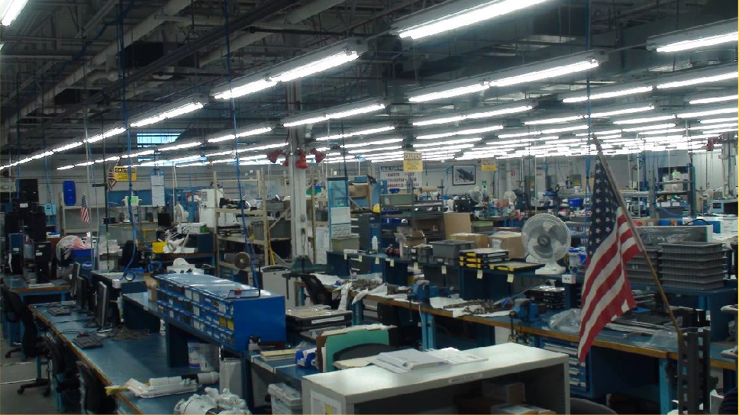

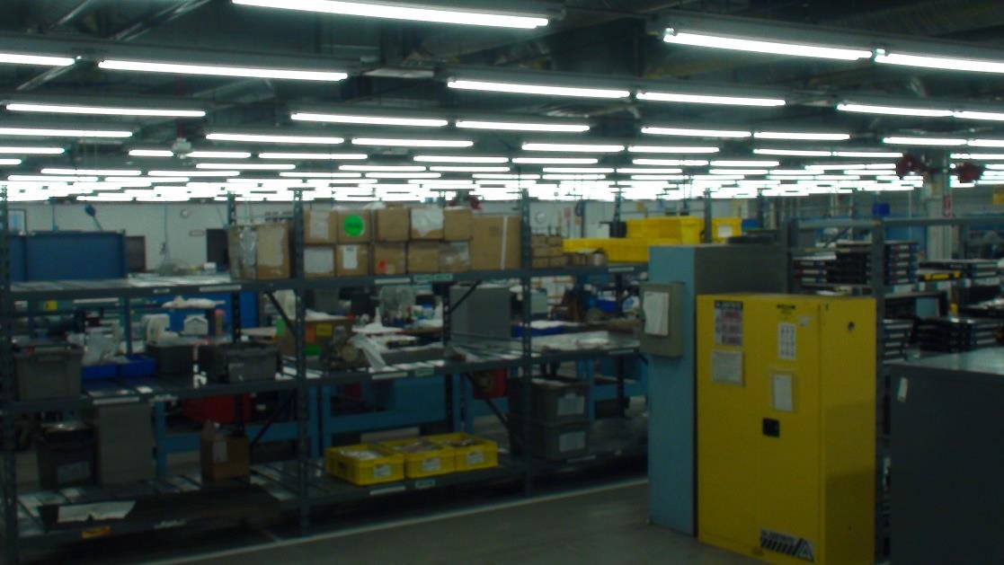
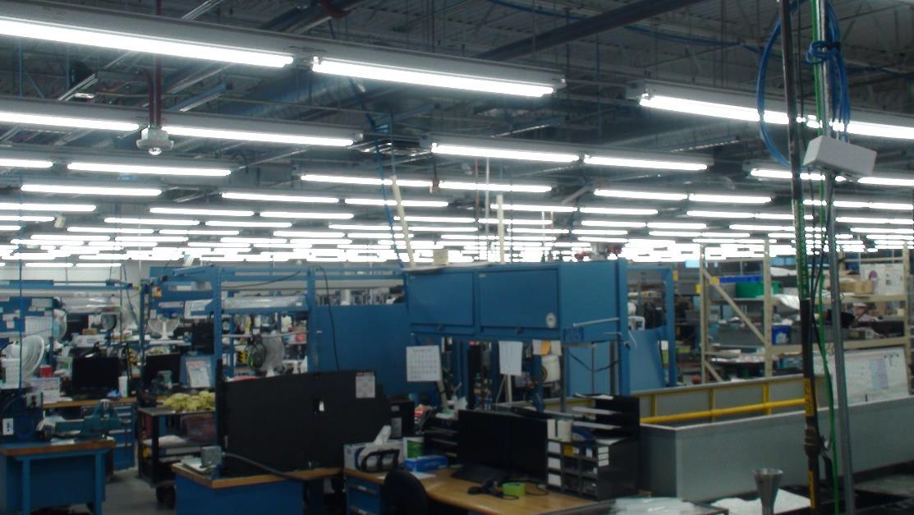

Fire Protection Questions
- Are we teaming with a fire suppression and fire alarm contractor during the design? Response: Yes.

- Is the project area currently sprinklered? Response: Yes.

- Are drawings of the existing fire sprinkler system available?
Response: See below for as-builts in archive. Drawings date back to as early as 1992, and contractor should field verify existing sprinkler configuration.

28

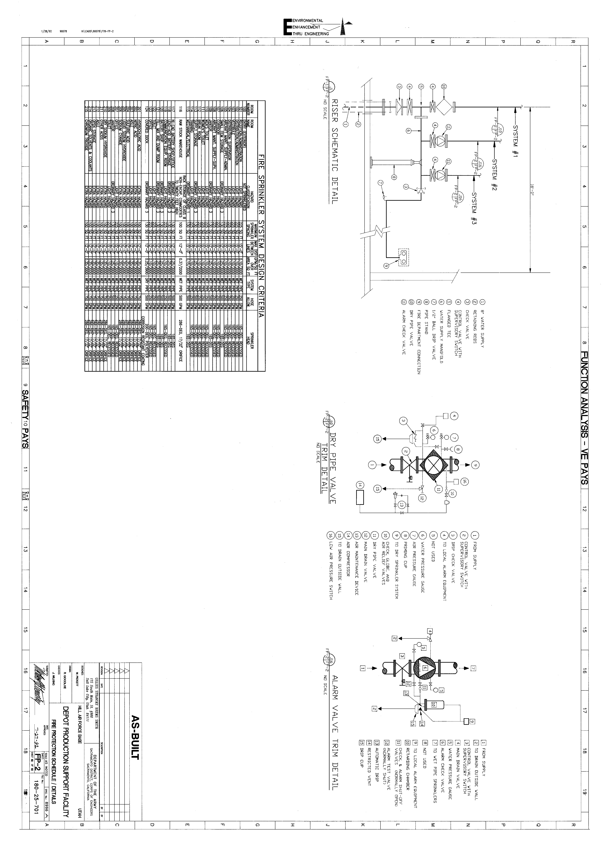

29

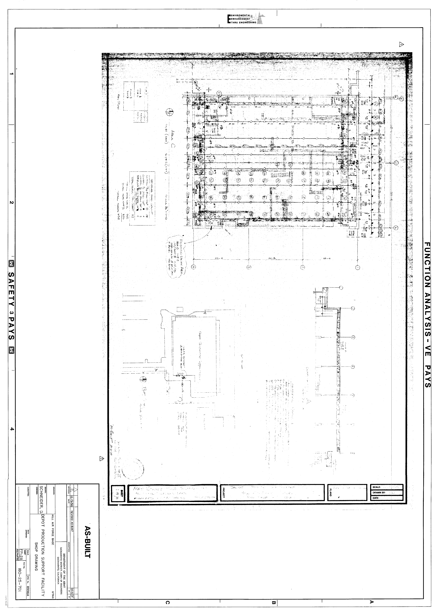

30

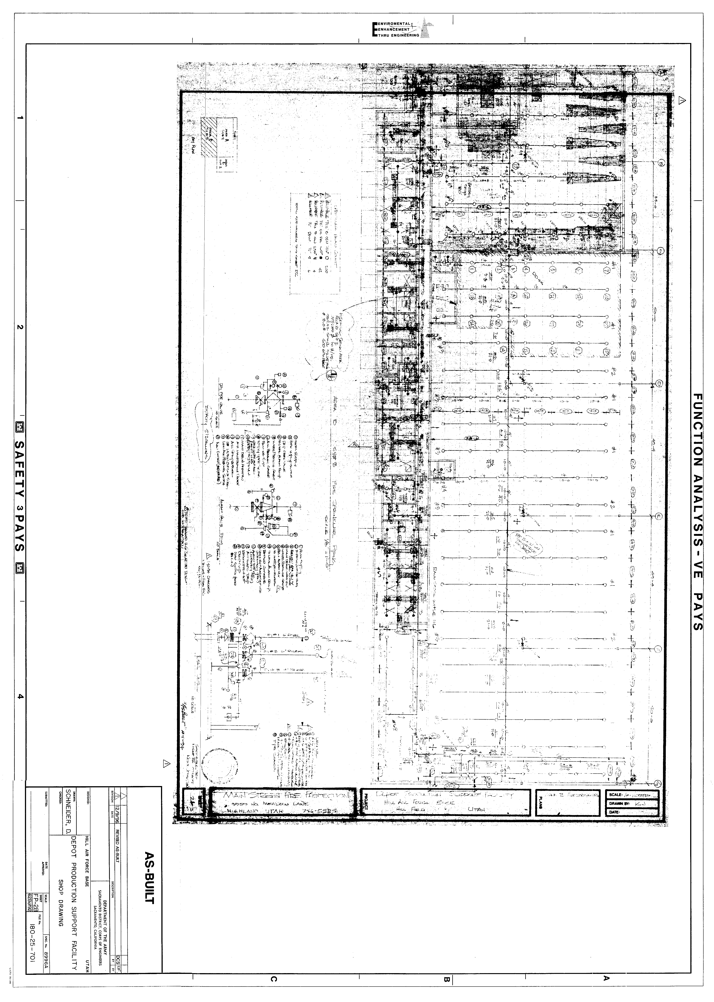

31

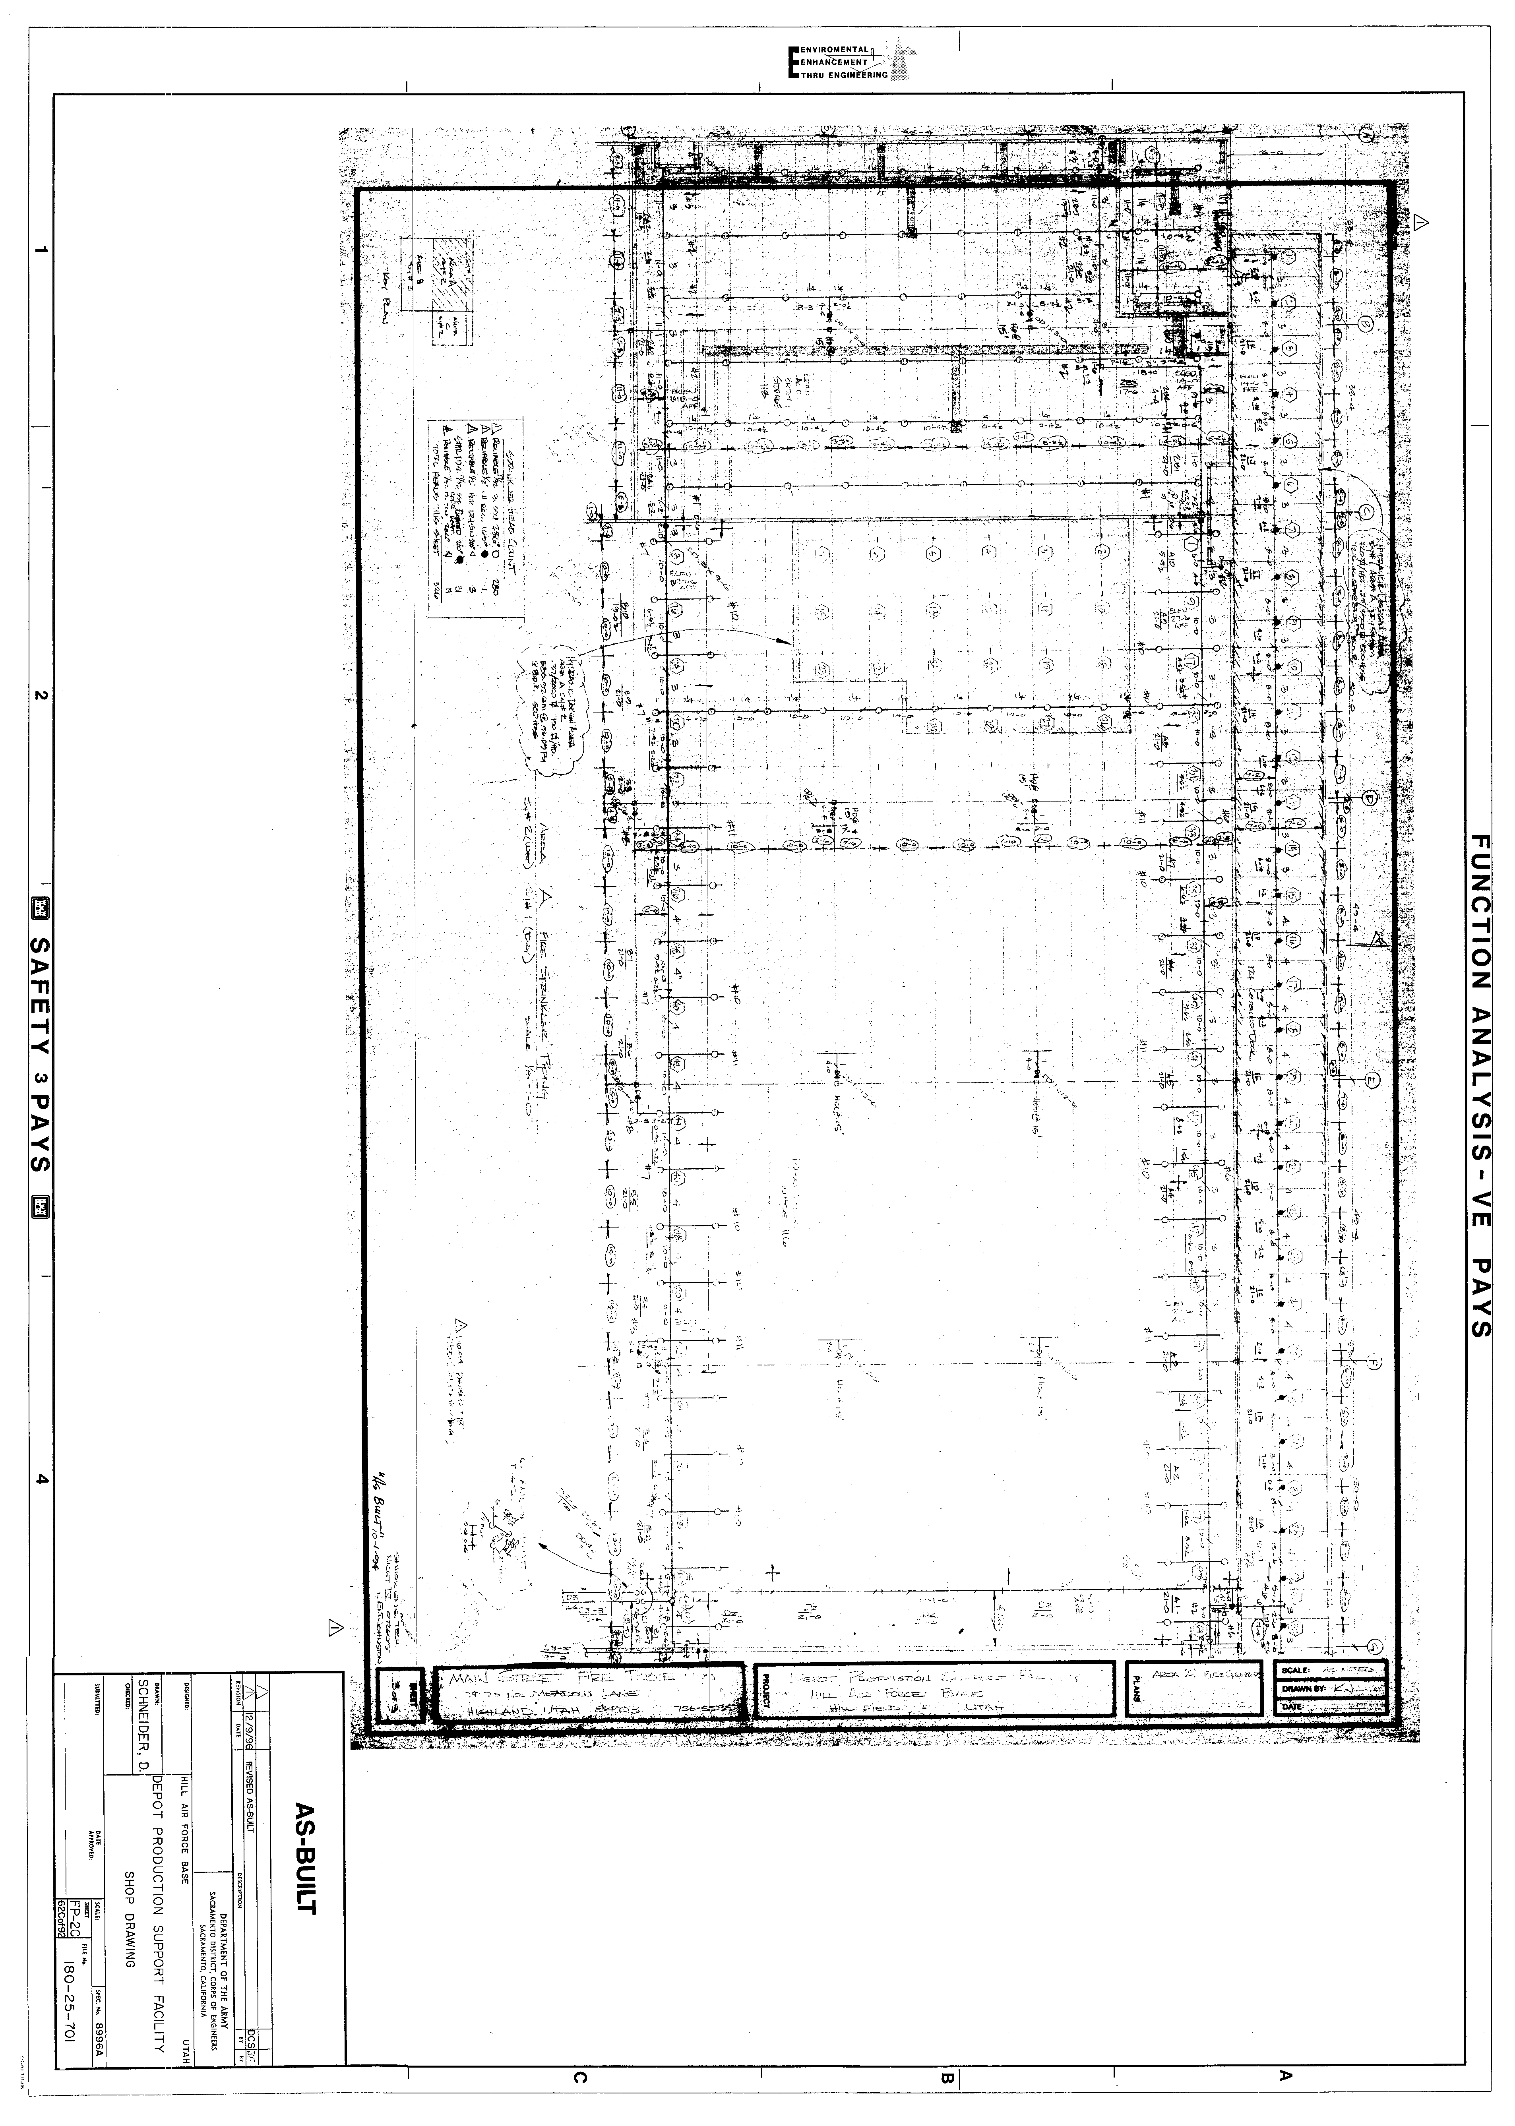

32

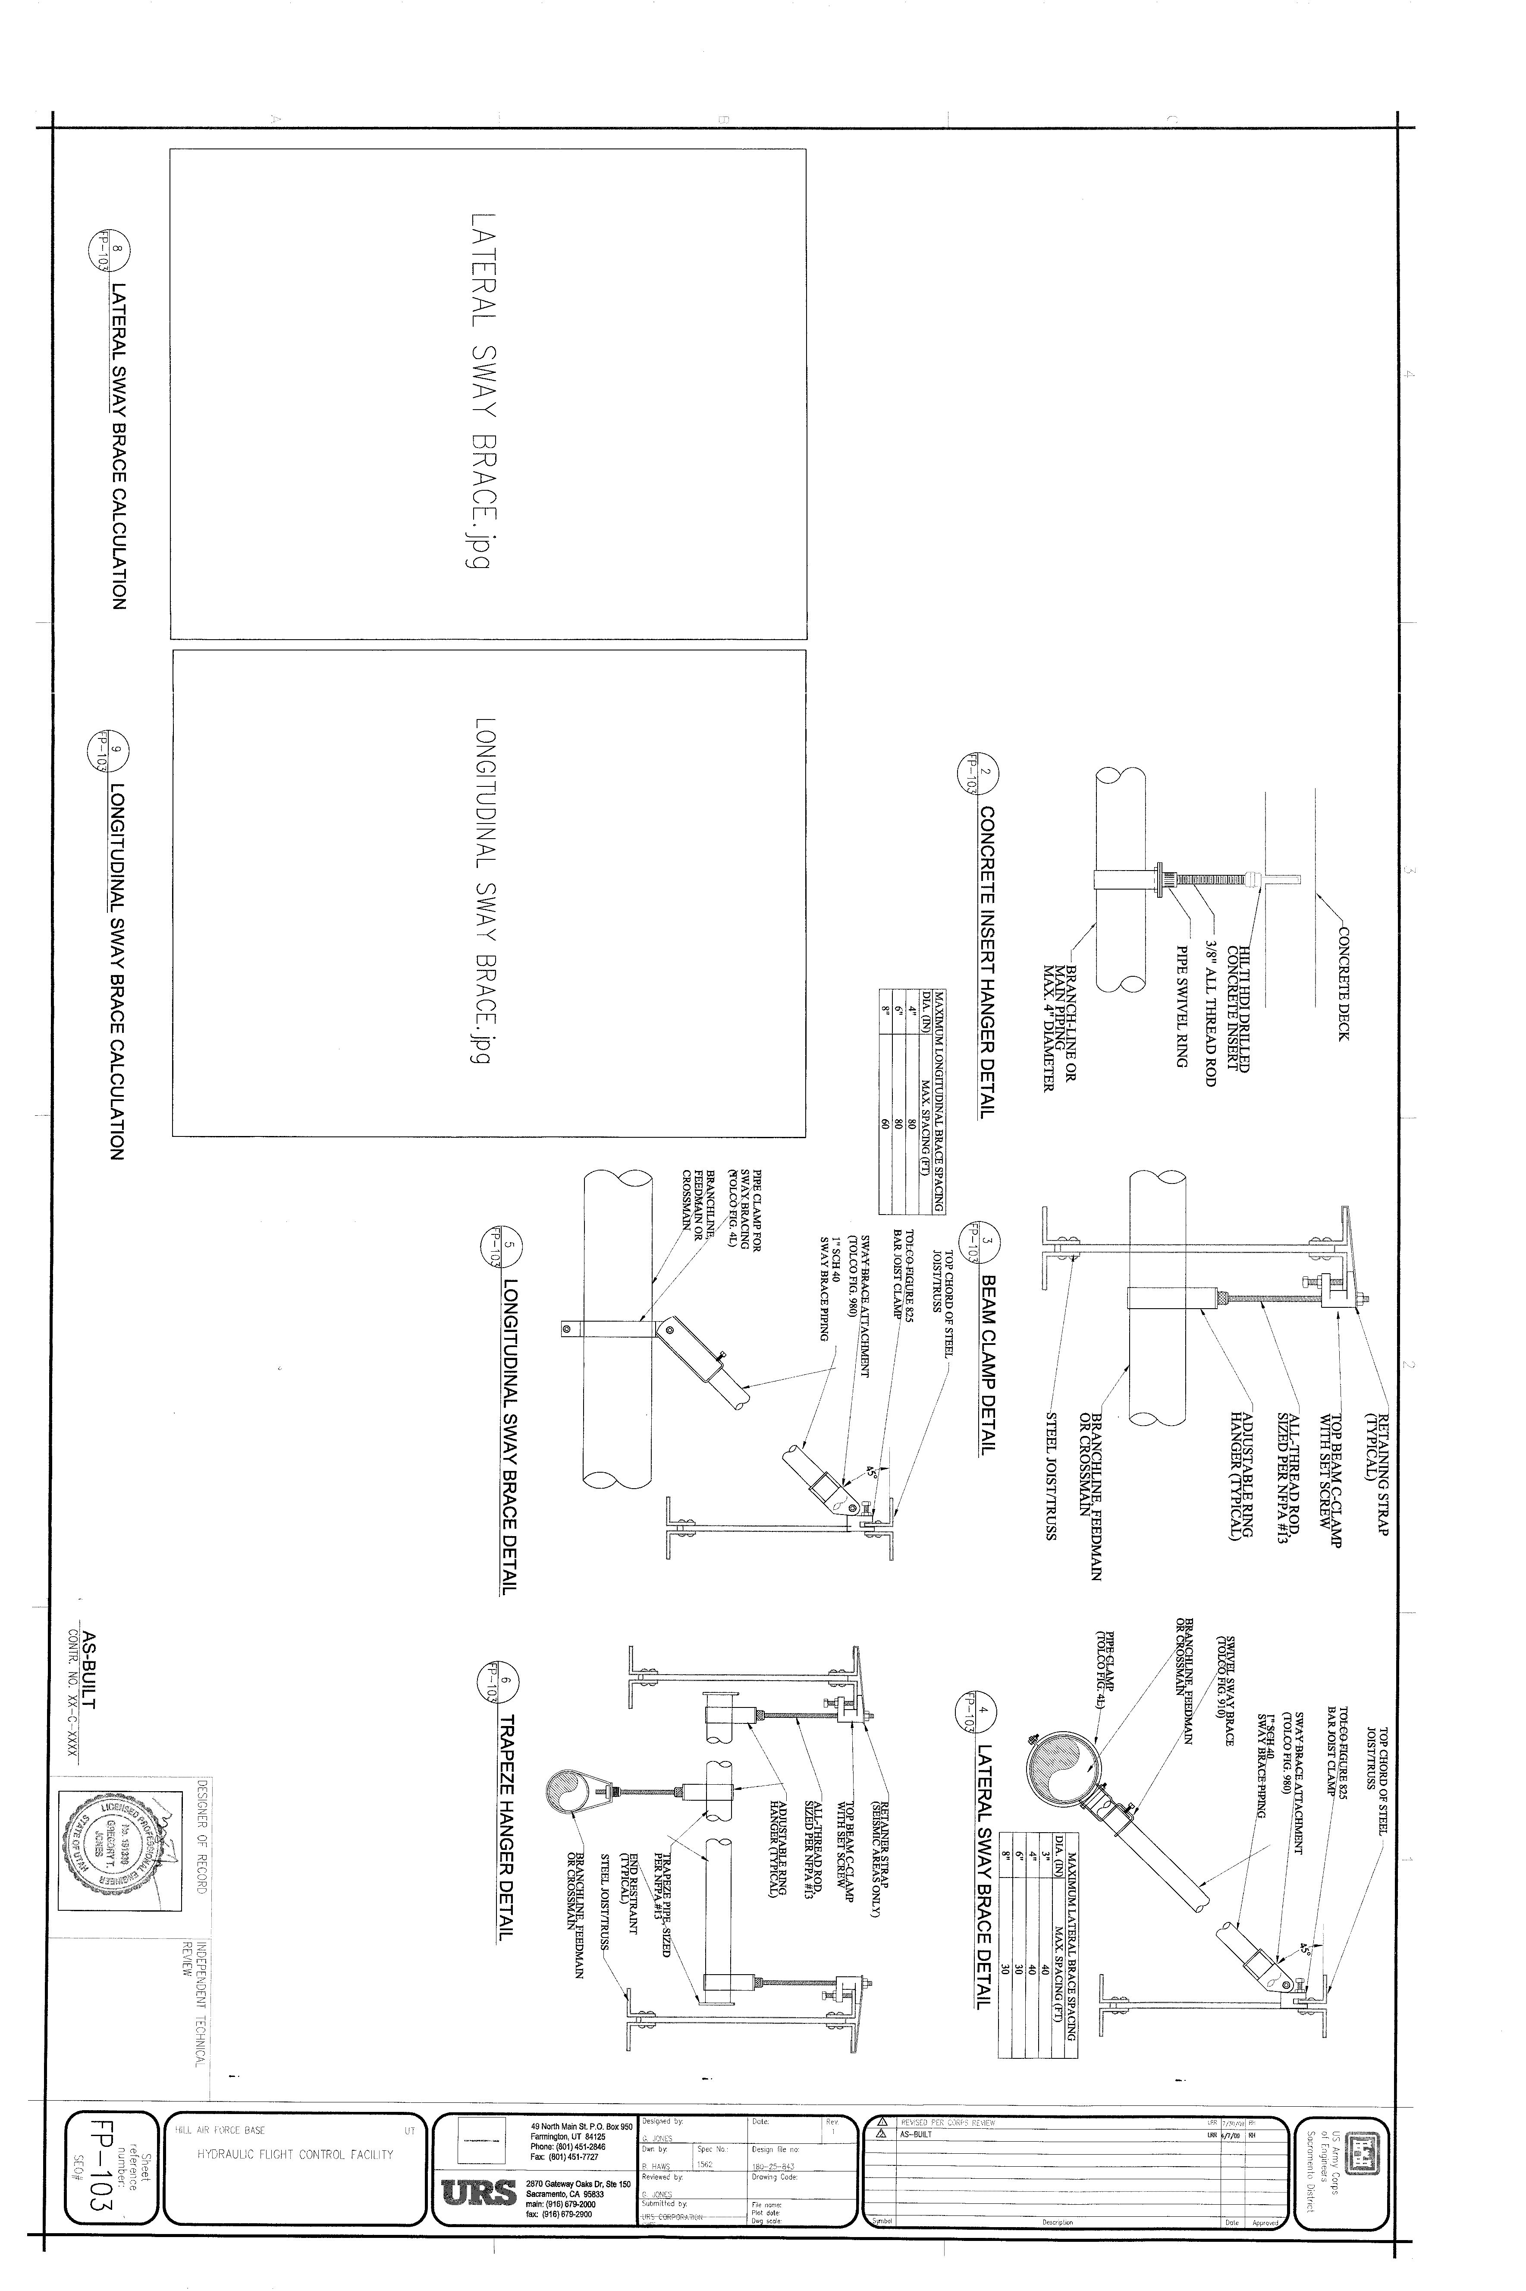

33

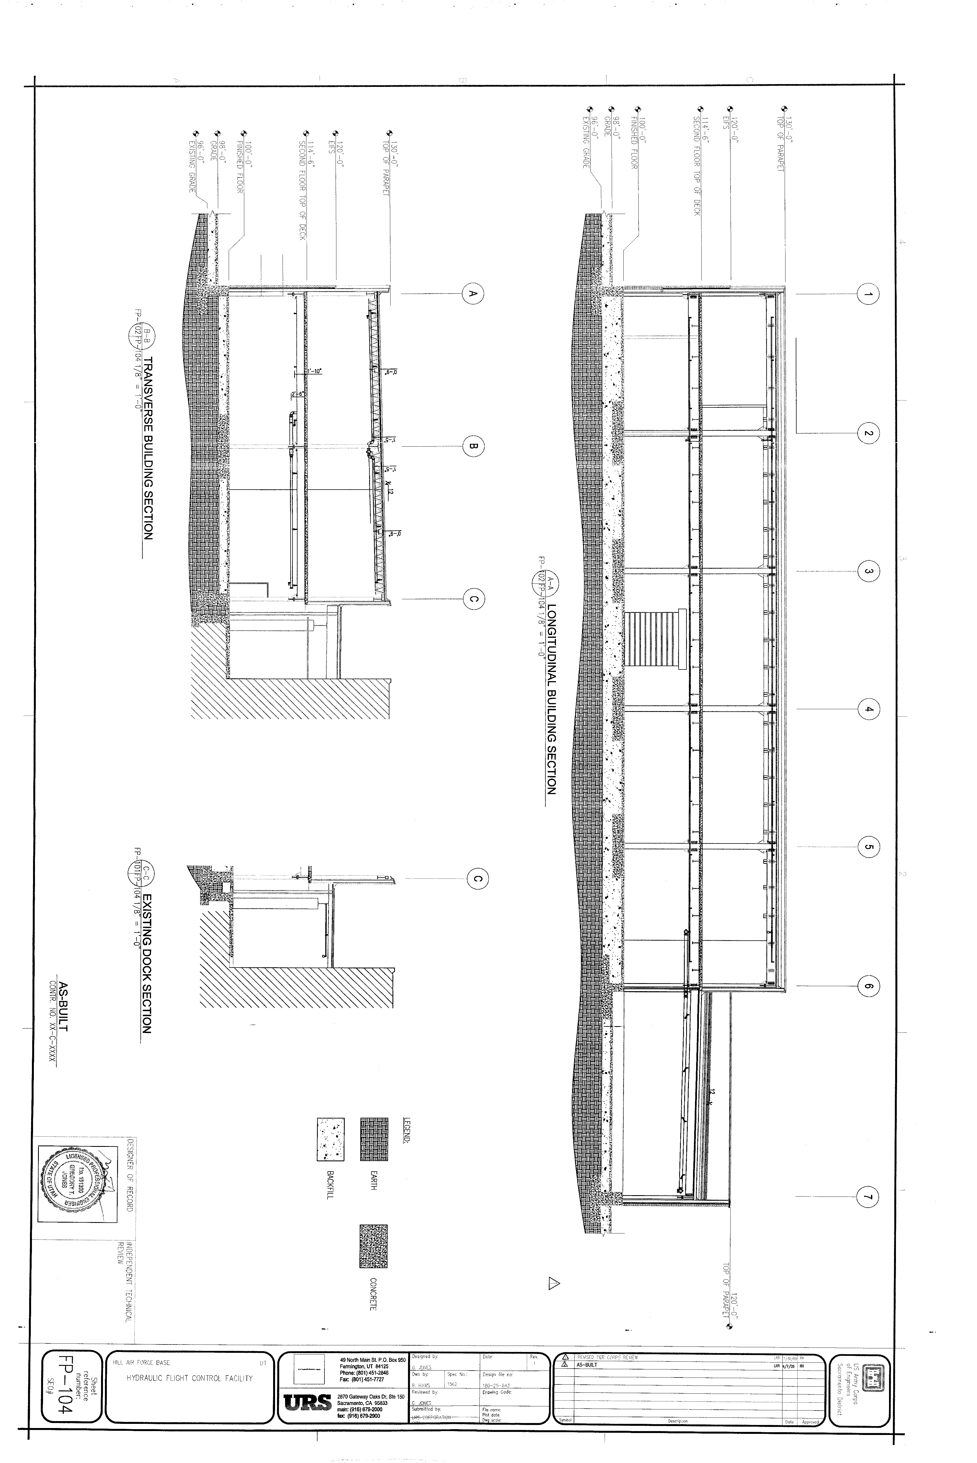

34

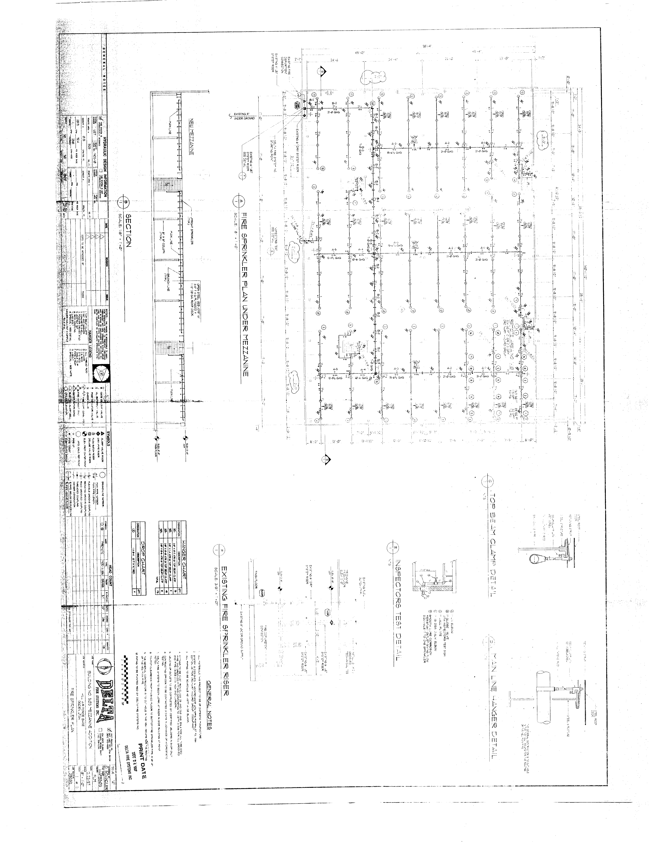

35

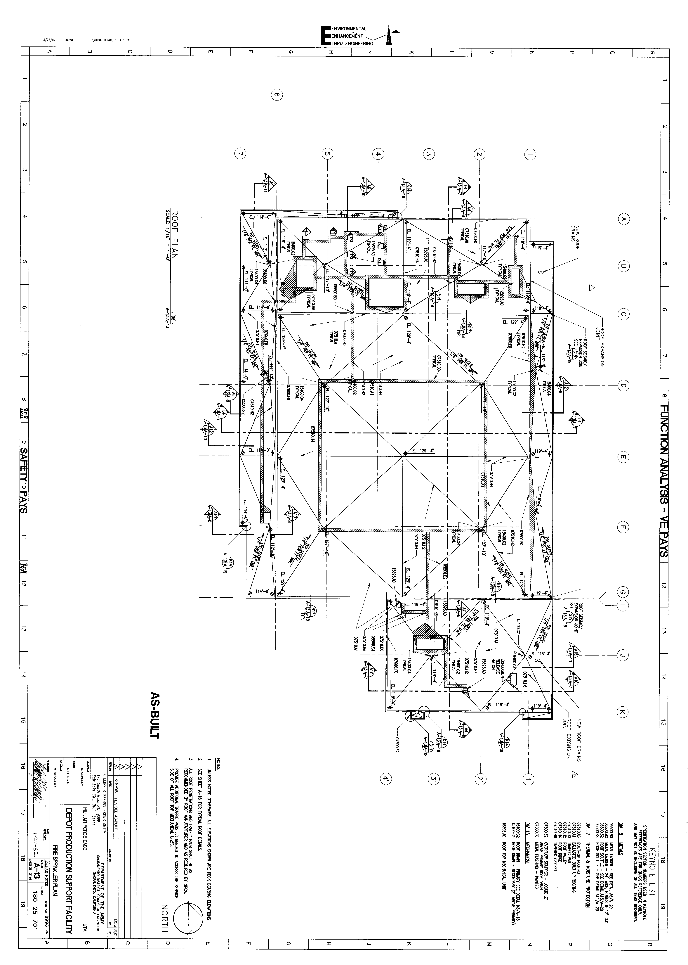

36

- What is the make and model of the existing fire alarm panel? Response: Gamewell Fire Control Instruments E3 Series
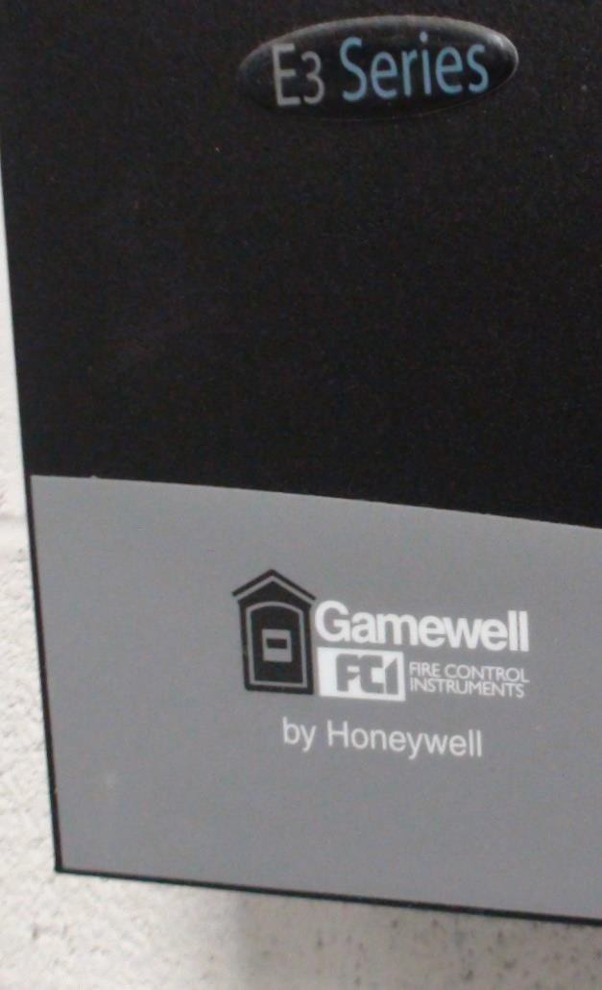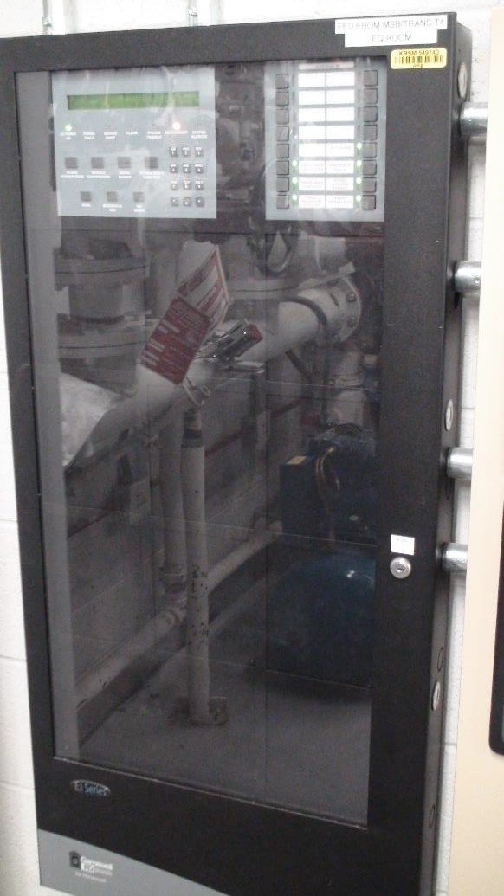

- Will work on the fire alarm system in the project area necessitate fire alarm/mass notification updates in the entire building?
Response: No, only the devices affected as part of this project.

- Are drawings of the existing fire alarm system available?
Response: Not available in our file archive. Here are pictures of the drawings are on the panel itself:

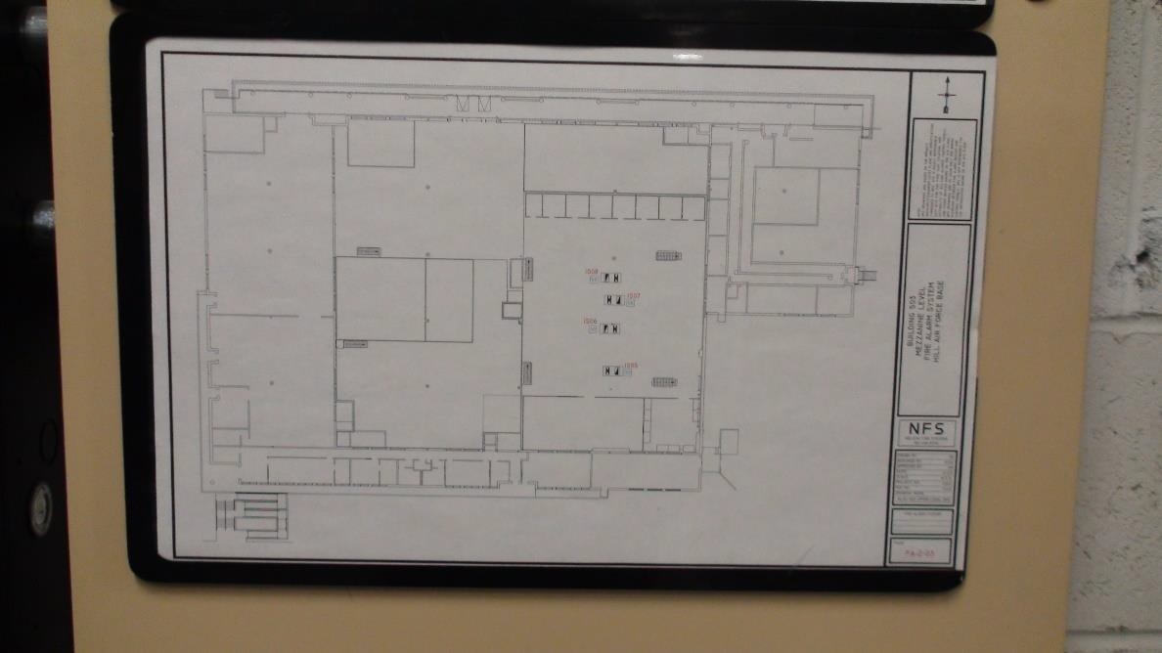
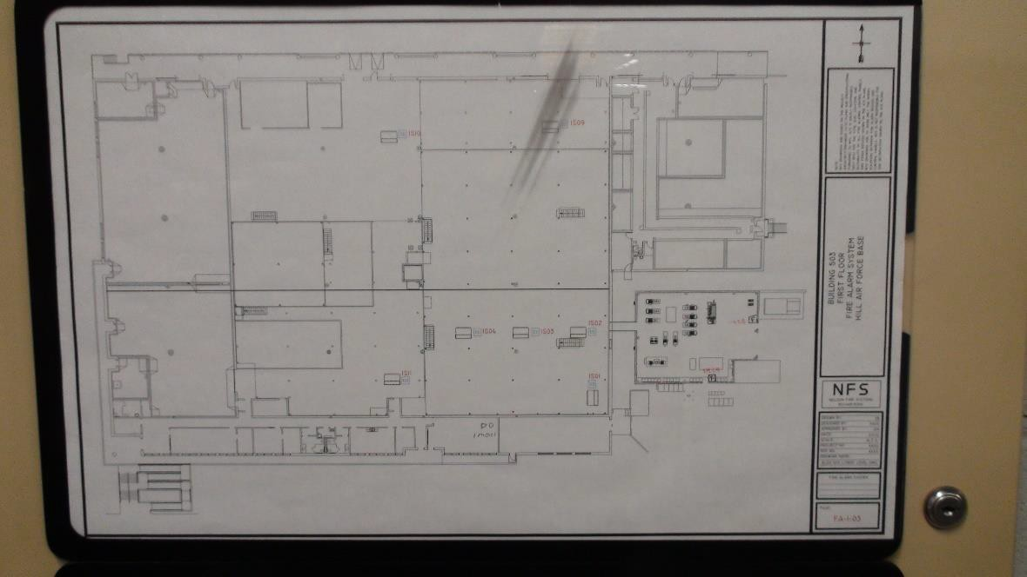

Mechanical Questions
- What is being produced in the shop? Are there any cleanliness requirements? Response: Several aircraft components are re-worked, tested, and produced. The space is a class 300k cleanroom.

- Is the compressed air system adequate for the new buildout? Response: Yes.

- Are there any new gases or processes being added to the shop? Response: No.

- What is the mechanical system serving the shop space? Will it remain? Does it have capacity to serve the new space, or will a new unit be provided?
Response: Existing mechanical/HVAC equipment is expected to meet demand, will remain, and additional mechanical equipment is not part of the scope of this project. Only the RTU detail in question 19 is to be included in this project.

- Will the AHU over the offices need to be replaced? If it is older than 12 years, we recommend replacement. Long lead times make repairing equipment even more difficult. Response: See question 19. Repair by replacement is acceptable.

- Is there hot water nearby for the eye wash? Does it have a recirculation line?
Response: Culinary heated water is available on south end of mezzanine, which feeds sink faucet previously used in the space when it served as a breakroom. No recirculation line.

- Are there existing drawings? Response: No.

- Are there filtration requirements for the clean workspace?
Response: Yes. Filters are the green hanging units in the space. Additional filters are not expected.

- Is it antiquated that all existing utilities are adequately sized for the new layout? Response: Yes, except for electrical. See question 4.

Electrical Questions
- Please provide pictures of the panel schedules for all panels feeding into the area. Response: See question 10 and question 41.

- Please provide locations in the rows for how work booths are currently being fed, with circuitry if possible. Home Run Locations.
Response: See question 39.

- It appears that lighting in the work area has been retrofitted from florescent to LED, the RFP stated to match existing fixtures with any new ones which will need to be ordered. Please provide what the existing fixtures are so that we can find out if they are even available. If it is deemed that the current fixtures are not a viable option, how much leeway will the government grant for any new fixtures needed to fill the work area space properly?
Response: See question 40.

- As the existing fixture layout will change nearly completely, please provide locations of the home runs for each row of existing fixtures, and the circuits if possible.
Response: See question 41.

- Please provide a VA load rating for each workstation for circuiting purposes. How many booths can we put on a circuit?
Response: See questions 10, 42, and 88.

- Are any dedicated high-power booths of outlets required in the work area? IG. 208V 3P 30A, 240V 1P 50A, etc. If yes, please state how many of what kind the government would like, and in what general vicinity.
Response: See question 89.

- If additional panels are required to meet the circuiting needs for the work area, please define governments preferred sources for power, and what provisions will need to be provided to feed new equipment. Where are the panels, we would be coming out of located? What is the voltage and the available current on said panels?
Response: See question 4.

- Does any of the equipment or machinery going into the new space have sensitivity to ground and required additional grounding measures.
Response: Yes, some workbenches require ESD/grounding. See the “Future Layout”, these workbenches are marked with ESD.
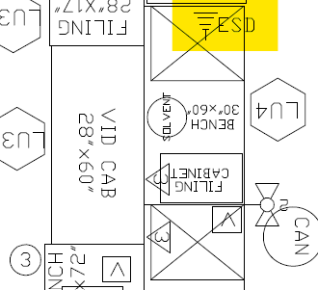

- Are their any specific power requirements needed for this space such as 400 Hz power, UPS, and/or back up power?
Response: No, not on the mezzanine.

- Are the new loads equal to or less than the existing equipment loads? Will we need to upgrade the electrical service to the building?
Response: Additional circuits are available in MDP and MCC-1. See question 4.

- What spaces are we going to need new lighting, and what spaces are we going to reuse and reorient existing lighting?
Response: Orient lighting above workbenches, hang from roof trusses. See images in question 46 for example of how lighting is currently mounted.

- I am assuming we will need to provide new lighting controls for new and existing light fixtures to meet updated energy codes, is that correct?
Response: Yes, refer to UFC 3-530-01.

- How old is the exiting electrical panels and electrical distribution? Is the intent to reuse existing branch panels for the space?
Response: Intent to reuse as much as possible.

- What is the load rating of the existing floor we are to replace the plywood on? Response: See question 1.

- What is the anticipated load with the new equipment configuration? Has any consideration to the weight of the new lather and hydraulic press on the existing floor? Response: See question 2.

- How many workstations can be taken out of service at a time and/or are there areas that you can indicate that can be taken out of service to assist in planning the changeover? Response: See question 3.

- Is it anticipated to need to have to add additional 208V panels to support the increased outlet count? Are there specific locations where transformers and panels can be added if needed? There are none shown in the concept layouts and Attachment 5 of the SOW is ambiguous on the number of outlets being added.
Response: Exact number of outlets will be determined by design. See question 4 for details regarding additional panels.

- Please provide model number for the existing electrical raceway we are required to match.
Response: See question 5.

- Please indicate the areas that has the spongy plywood on the floor that are of concern. Is the plywood spongy from leaking on to it or heavy equipment on it?
Response: See question 6.

- Is it intended for the utilities to come up through the mezzanine floor or be dropped from above? If the utilities are to come up through the floor will the area under the entire mezzanine be available or will the work have to be staged similar to the mezzanine work? Response: See question 7.

- What is the existing lighting foot candles in the area where additional fixtures are stipulated in the SOW?
Response: See questions 8 and 40.

- Provide the details of cleaning, leveling, and refurbishing the existing floor as described in the SOW.
Response: See question 53.

- Please provide the existing electrical load for the panels on the mezzanine. Response: See question 10.

- What is the desired height of the stanchions? Response: See question 11.

- What is the spacing of the stanchion supports for the raceways? Response: See question 12.

- Is stanchions made of Unistrut components acceptable? Response: See question 13.
- Is the mezzanine decking truly required to be demoed? I think it much easier solution, and so all the generals are on the same page will be a grind and epoxy. Tearing up all of the decking and replacing will be a nightmare, especially with employees underneath trying to work. If it is a requirement, though, please specify exactly how it’s to be done so it’s bid the same way across the board.
Response: Government preference is to replace decking, but repair is an option if removal is
deemed infeasible. Method is at the contractor’s discretion. See question 53.

- Can we get clarification on what utility’s that they want at the benches? And are they wanting us to replace the compressed air in that area with copper or just leave what they have and add new black pipe where needed for the new layout? And can we get a new layout of the work benches so we know how many to plan for?
Response: Future layout is provided as an attachment, with power, air, and grounding requirements listed. No need to replace steel air lines with copper.

- Are any new workbenches required or are we just relocating the existing? Response: Just relocating existing benches.

- Fire Suppression- Would the Gov like to have the Sprinkler heads changed to New in the North Offices?
Response: See question 18.

- Will new Eyewashes, or the existing Eyewashes, need tempered water? If so, where would a water heater be placed, and what type would it be?
Response: Yes, per ANSI Z358.1-2014 all eyewashes need to be tempered between 60F and 100F. Water heaters to be on demand, or use existing hot water lines located on south end of mezzanine that feed the sink when the space was previously used as a breakroom. Locate on demand water heaters adjacent to eyewashes.

- The scope calls out for (2) new Eyewashes to accompany the (2) existing Eyewashes. There are (5) on the provided drawings. Are we to supply (3) new Eyewashes?
Response: Yes, provide three (3) new eyewashes.

- Is there a 120/208V panel close by? And if so, how far is the panel?
Response: Panels LE and LE-1 are located by the southeast stairs. New panel(s) will be required for additional circuits. See question 4 for more information.

- What are the power requirements for the new workstations and offices noted? Response: New electrical changes for the offices. See question 4 for information regarding available 480V circuits that can be used to for 120/208V transformer and additional panel(s).

- What are the lighting requirements for the new workstations and offices noted? Response: See question 8 for lighting requirements on mezzanine. No lighting changes in offices, as these fixtures are part of ESG energy contract – see question 40 for additional details.

- What are the data requirements for the new workstation and offices noted?
Response: Install two data ports every 60” on the wireways so network and data are easily available to each workbench. Communications room is located on northwest corner of mezzanine. Reuse comm. ports currently feeding workbenches. Currently, there are 34 additional ports available on the switch. Notify government PM if additional switches are required, which need to be purchased through the Hill AFB Comm. Squadron.

- Will we be able to reutilize any existing circuits from the demo portion of the mezzanine?
Response: Yes.

Late question 1/18/2023

- The SOW section 1.1.1 states “Install new double doors on walkway connecting building 503 to building 503A. Doors shall include necessary fire protection hardware, motorized ADA hardware, and ASSA locks. The new doors shall not use a mullion to ensure ease of passage for carts, assets, and personnel.” These doors were not shown at the site visit and there is no other information to help understand existing door type, sizes, etc. Will the government please either provide more information on these doors to be replaced and possibly a couple pictures of the existing doors?
Response: Doors on north end of walkway do not currently exist. See pictures below. Walkway construction was in progress when SOW was written, and cased jam may complicate door installation of full-sized double doors. Cased jam is 57” wide x 90” tall, then 72” wide x 99” tall past the jam once in the walkway. Investigate as part of design as building 503 needs to maintain a slightly pressurized environment to satisfy clean room requirements. Alternatively, provide new motorized doors with seals, ADA buttons/hardware for both directions of travel on doors on south end of walkway, also pictured below.

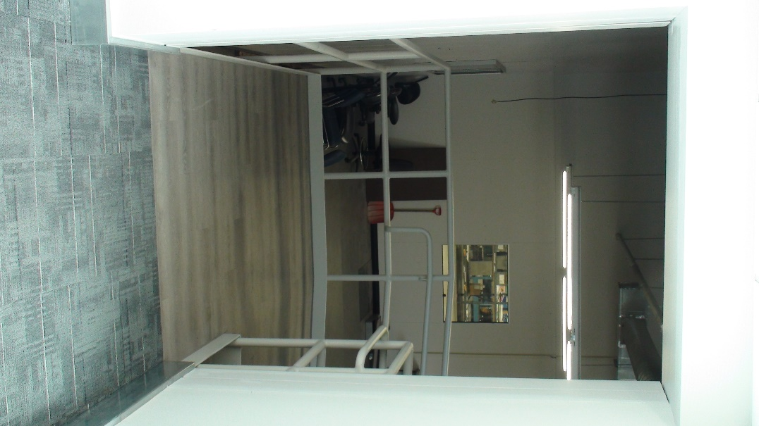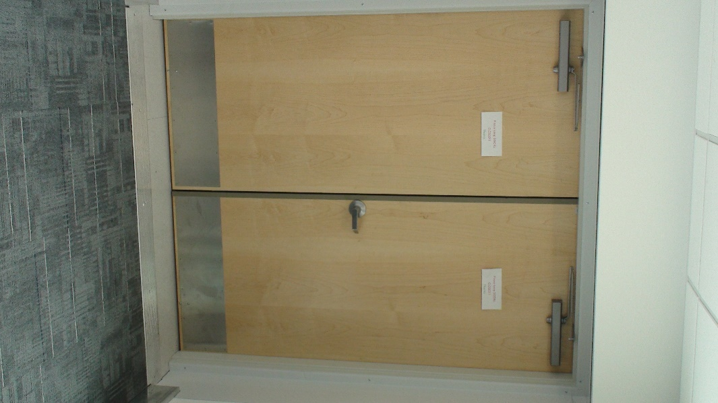
Pictured above: (Left) view of north entrance and ramp into “skybridge” walkway connecting building 503 to 503A. Dimensions of opening are detailed in the response above.
(Right) Existing doors on the south entrance, leading into building 503A.

Late question 1/19/2023

- The scope of work section 2.2, and the utility drawing do not indicate how many feet to demo or if there are any utilities at the building. They do not indicate the pipes sizes or the main sizes. Each one of these building could have been built for storage only so by saying, “would normally be expected for a complete demolition project” could be interpreted as there are no utilities. We need to know the pipe size, length going to the building and at the main of each utility so section 2.2 can be understood and there is a clear understand and expectation from all parties.
Response: Section 2.2 pertains to design milestones and drawing requirements. Demolition is discussed in section 2.27. No abandoned network, electrical fixtures, conduit/wire, air lines, fire suppression, plumbing, etc. shall be left in situ at the completion of this project.
Lengths and diameter compressed air lines that may need to be demolish back to the 3” loop are estimated after the figure below. Each group of workbenches has a drop for air and electrical that run up to the nearest overhead air line (see image below), or back to panel LE1. Overhead conduit is approximately 10’ above the mezzanine floor, air lines are approximately 10’8” above mezzanine floor. Steam and condensate lines located along east wall are approximately 13’ above floor, domestic water line at 11’, light fixtures at approximately 9’4”. If more accuracy is required at this stage, please contact the Facility Engineer POC Matthew R Larsen at 801-586-1535 or matthew.larsen.13@us.af.mil to arrange a site visit.

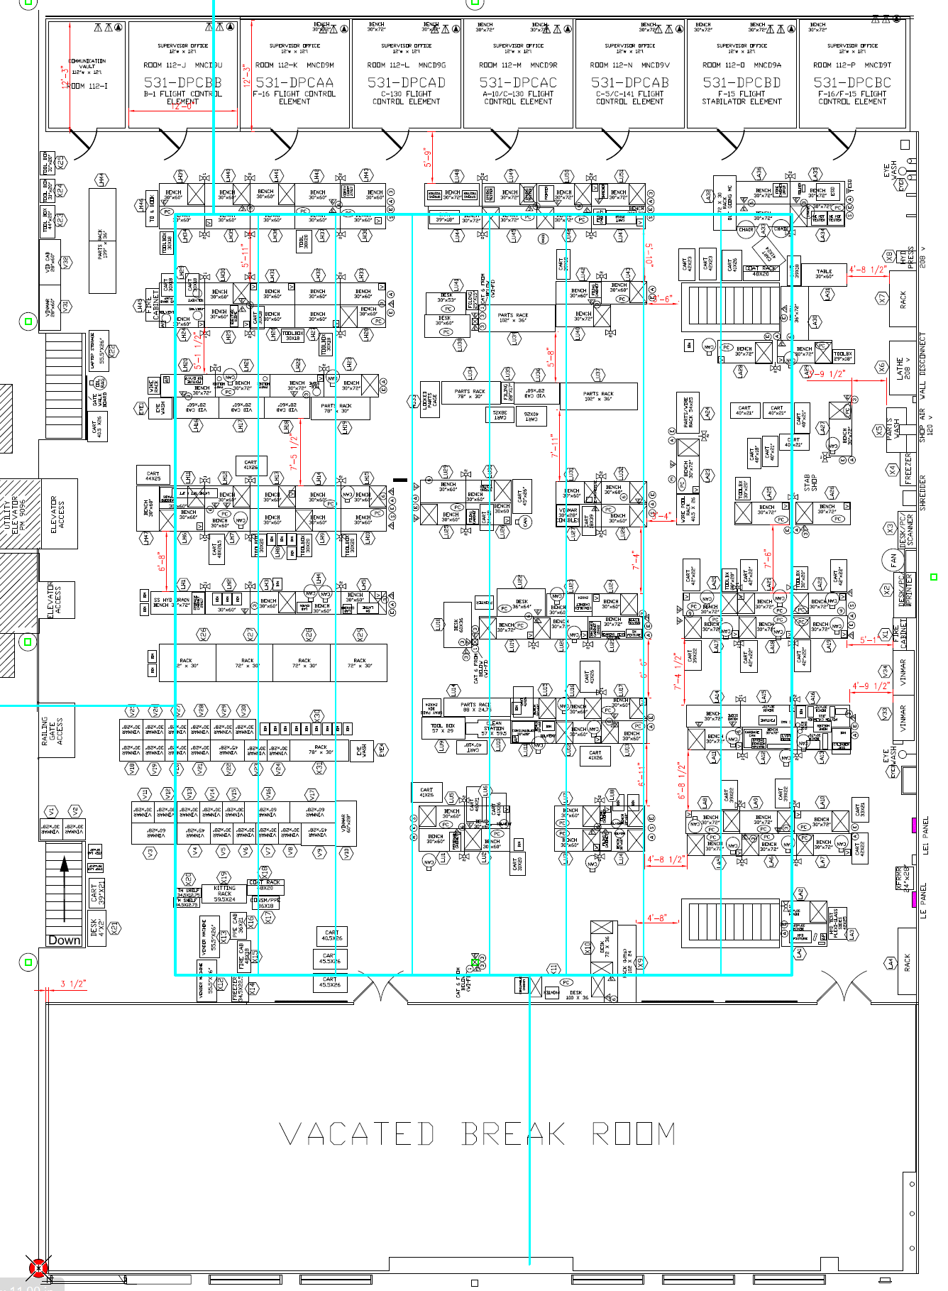
Note: Blue lines show overhead compressed air lines. Magenta boxes along the right (east) wall indicate electrical panels feeding workbenches.

~700’ of 1” black for compressed air (7 lines connected on both north and south ends to 3” loop)
~450’ of ½” black (air drops to individual workbenches)
~350’ of ½” copper (air drops to individual workbenches)
~40’ of 3/8” stainless steel (abandoned air drop in SE corner)

*Measurements above are estimates, contractor shall field verify any and all dimensions in this document.*

Below are several additional pictures showing the electrical/air/steam/water/fire suppression lines that penetrate the north wall of the breakroom wall being demolished, along with bench drop and panel details.

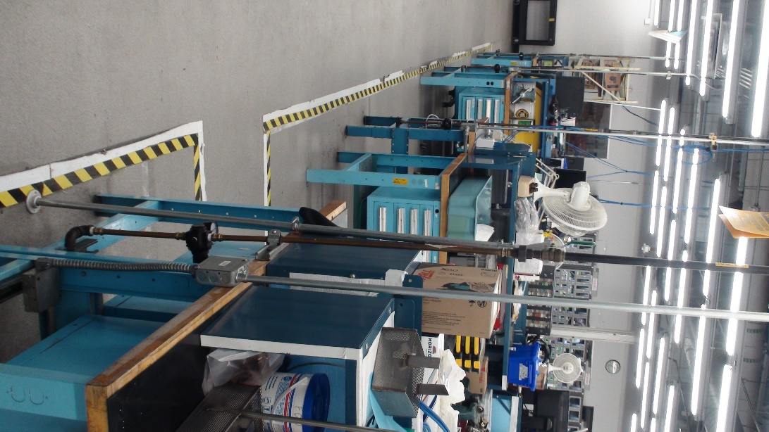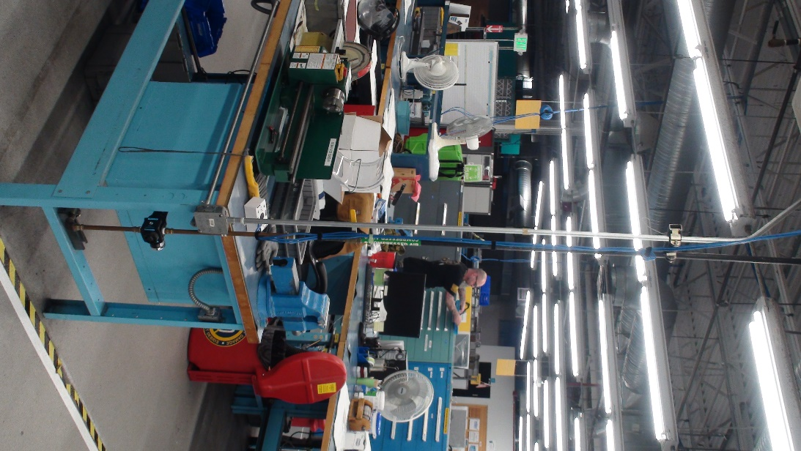
Above are two examples of the air and electrical drops to the workbenches. Air and power are run below benches to individual connections/receptacles at each bench. The picture on the left also shows one of the air sampling ports coming up through the floor.
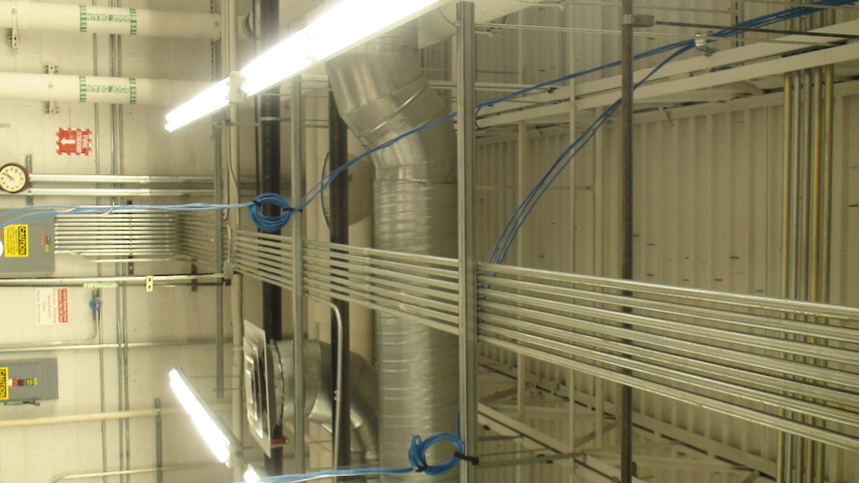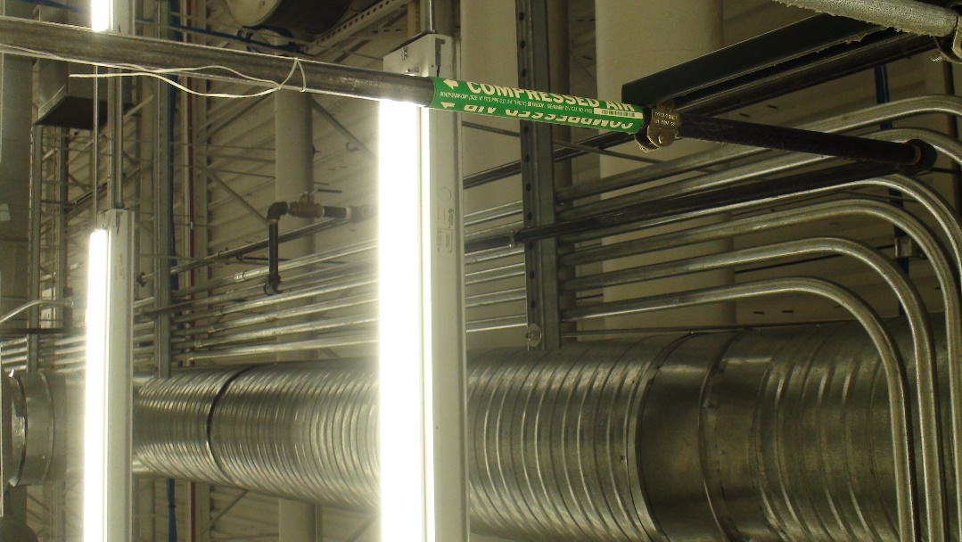
Pictured above are some additional views of the overhead power and air drops feeding the workbenches.
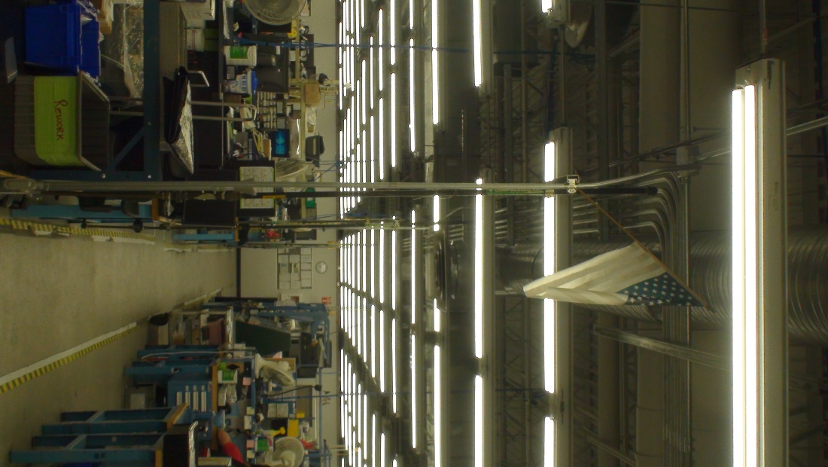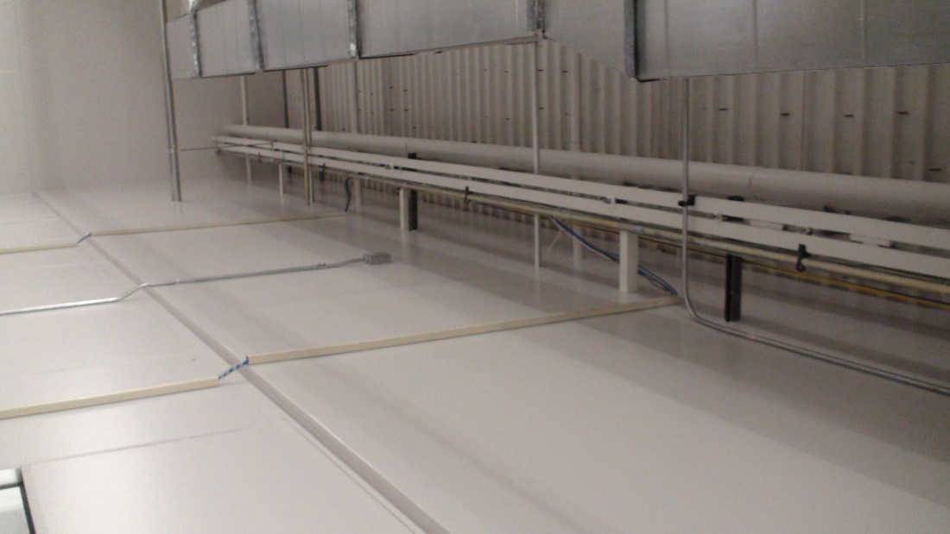
Pictured above: (Left) Electrical conduit run overhead above the aisle to the drops at each group of benches. (Right) Some fire suppression lines that penetrate the north wall of the breakroom. This wall will be demolished.

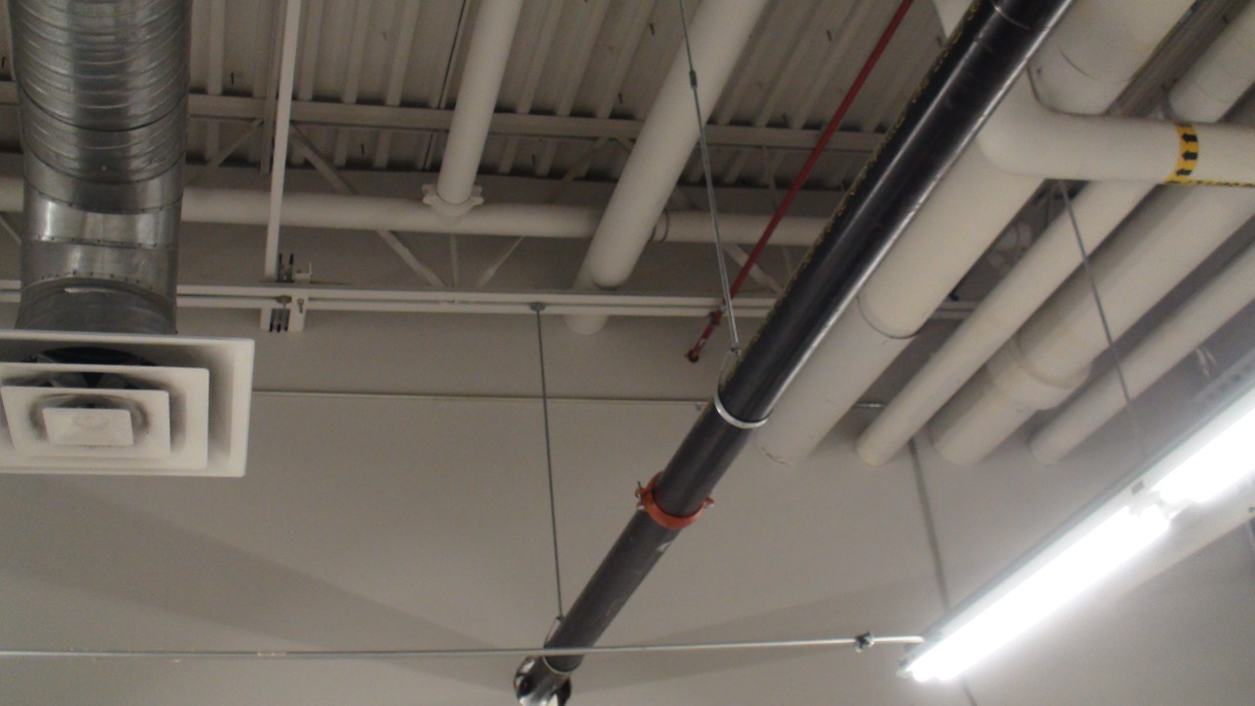
Pictured above: Steam, condensate, domestic water, fire suppression, and fire alarm penetrating the north east section of the breakroom wall. This wall will be demolished.

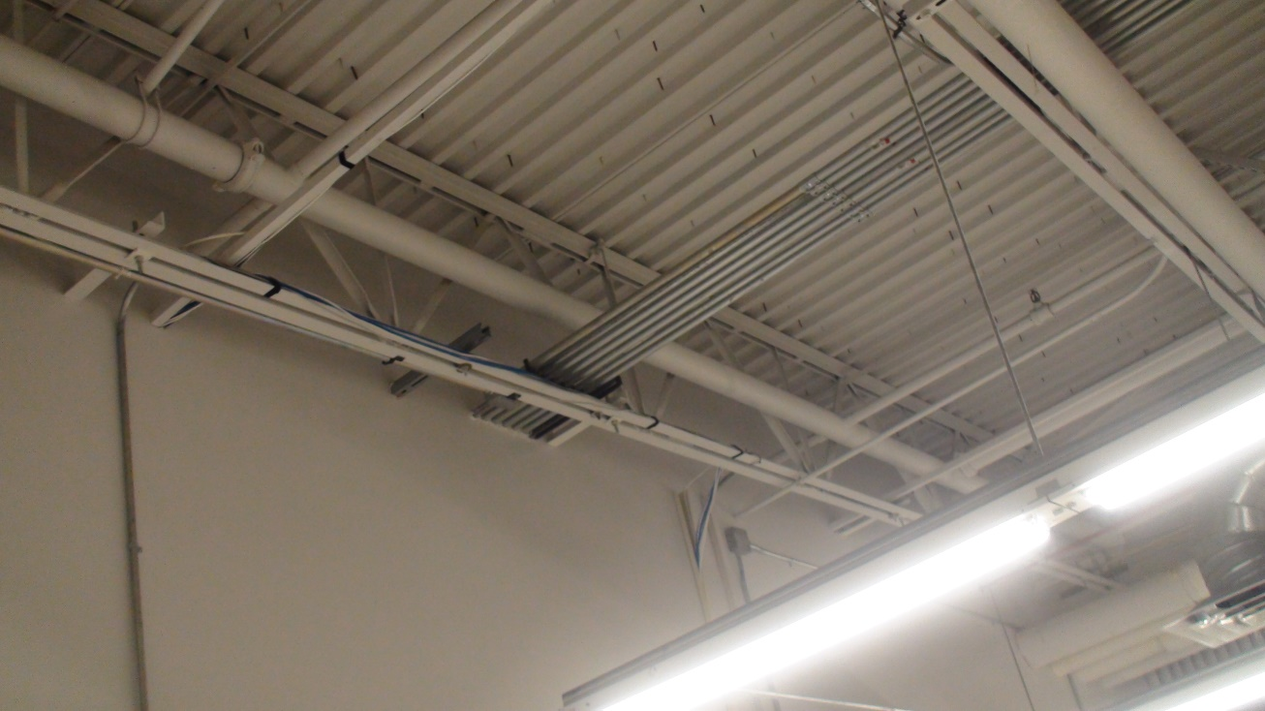
Pictured above: additional electrical conduit that penetrates the north breakroom wall. This wall will be demolished.

Late questions 1/25/2023

- In the previous RFI’s Q 53 and Q 140 answers, is still very unclear on patching versus replacement. Could you please clarify. My observation to this is that if you choose to patch, you will not have the ability to get a warranty on it. If you replace, then you have grounds for a warranty.
Response: Per Q53, please provide quote to replace all plywood flooring except what is under the supervisor offices on the north end, and what is under the ramp on the south end. Warranty to cover material and workmanship of all replaced floor panels and epoxy floor coating. If replacement of all plywood flooring is not possible, give detailed explanation why, and provide quote for the quantity of patches described in Q53. Warranty will then apply to the materials and workmanship of the areas repaired, and the epoxy floor coating.

- A question in the previous RFI’s mentioned that the walls need to come down in order to Remove the plywood. The answer was a carpet remark. Please verify
Response: Q34 and 54 both state that only the carpet in the offices will be replaced, not the plywood as that would require the offices to be dismantled. If you are referring to another RFI, please specify which question you need clarification on.

- Does this project have to have a 1-year warranty on it. If so, there will be some issues arising from some responses to previous RFI questions.
Response: Yes, all constructions projects must have a one-year warranty period under the MACC IV.

