ROMO 160755 – 2nd Site Visit April 18, 2022, 10:00 AM MT

Meet at the Bighorn Ranger Station. Take the first right past the Fall River Entrance.
Drive past the “Authorized Vehicles Only” sign and up to the Ranger Station Building.

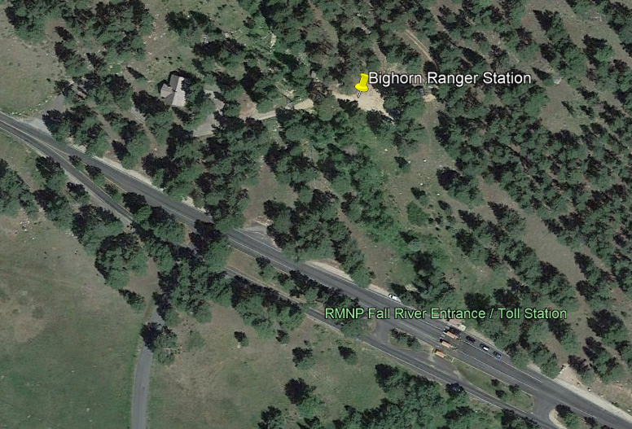
Turn right here

Call Tim Burger with any questions 720-688-9530

